 | European Schools  Office of the Secretary-General of the Board of Governors
Ref.: 2008-D-172-en-2
Orig.: EN

ICT Report for the year 2007
Board of Governors
Meeting on April 2008 in Helsinki
Summary
The ICT Report presents to the Board of Governors the development of ICT in the European Schools and at the Office of the Secretary-General of the Board of Governors.
This report:
- assesses the results achieved in 2007
- describes the outlook for the year 2008
The report’s presentation provides the Administrative and Financial Committee with an opportunity to give the advice and instructions which it deems appropriate.
The document has been presented to the Administrative and Financial Committee at its March meeting in Brussels. The AFC said that it was a good report and they suggested to add some reflections about the general strategy of ICT at the European Schools and to add comparative tables about the differences of the use of ICT among the schools.

ICT Report for the year 2007 1
ICT Report for the year 2007 3
1. 2007 results 3
1.1. ICT Steering Group (ICTSG) 3
1.2. End of development and start of the pilot phase of the new administrative applications 3
1.3. Infrastructure for the Data Centre 4
1.4. Evolution of the Learning Gateway 4
1.5. The European Schools’ eLearning Competition 5
1.6. Deployment of a new version of the management report software 6
1.7. Brussels IV and the enrolments for the Brussels Schools 6
2. Outlook for 2008 6
2.1. Deployment of the new administrative applications 6
2.2. Deployment of new DADEE (DOCEE) 6
2.3. Standardization of a dashboard of pedagogical and financial indicators for the evaluation of the schools 7
2.4. Replacement of the administrative PCs 7
2.5. Replacement for Class Server 7
2.6. Second edition of the European Schools’ eLearning Competition 7
3. Use of ICT in the European Schools: 7
3.1. ICT across all ages 8
3.2. Teacher and staff training 8
3.3. Distance Learning lessons 8
3.4. Evaluation of the use of ICT 9
3.5. Examples of the use of ICT 9
4. Distribution of ICT material in the schools: inventory by 31 December 2007 10

ICT Report for the year 2007

2007 results

ICT Steering Group (ICTSG)
Information and communication technologies (ICT) play important role on all sectors of the schools. ICT are regarded as a tool shared among all the schools which respects their autonomy but harmonises their administrative management (accounts and financial, staff and pupils) to a greater extent.
The ICT Steering Group (ICTSG) was set up to support and assist the ICT Unit in making the necessary technical choices, with respect to both tools and specific application programs developed for the schools. The Steering Group does not take political decisions but recommends technical choices.
The Steering Group met two times during the year 2007, on June and January. Its work involved monitoring the different ICT activities at the OSGBG and the schools. A significant part on the meetings was devoted to discuss and analyze the school’s ICT budgets according to the figures of new ICT Plan. The Distance Learning projects and the strategy for deploying the Learning Gateway was also a recurrent matter in all meetings.

End of development and start of the pilot phase of the new administrative applications
The European Schools use a range of computer application programs for the administrative and financial management of the schools. Those applications have reached the end of their useful life and they will be renewed. After a call for tenders process on 2005 the winning company started its work on January 2006. During the first half of the year 2006 a complete analyse including the integration of all modules was done, resulting on a process reengineering. The development phase started on the second half of the year 2006 and was scheduled to finish by June 2007.
During the first half of the year 2007 the ICT Unit, with the help of administrative staff of the Office of the Secretary General and the Schools, started the initial tests of the new software; the developers produced several prototypes that were debugged by our staff. According to the feedback of the pilot users some missing and new functionality were identified and either corrected or scheduled for future versions.
On June 2007 all the new developments for the pupils and staff management were practically finished and ready for the pilot phase. However, the integration of the financial package was not mature enough. Several things were still pending but the financial provider said that everything would be ready for the beginning of the school year.
We took the risk of starting a pilot in the new school of Brussels IV because it seemed an ideal situation: a small school with a reduced number of students, a reduced number of staff to train, and a brand new ICT infrastructure. The tests were very promising with the exception of the financial package, and after several problems we were forced at the end of the year to install the old financial package at Brussels IV.

Infrastructure for the Data Centre
On the year 2003 the Office of the Secretary General’s Data Centre included very little equipment (about 7 servers) and relative few services. This number has been multiplied by five and the use of the equipment has been extended from the standard business hours to virtually all time. Administration staff needs to access their mails on the weekends or on the evenings and teachers and students uses the Learning Platforms at home at any time.
The European Schools ICT support is relatively poor as the ICT unit and the ICT support at the schools is understaffed. Moreover, the support is only guaranteed at working hours and all the centralized applications depend on the working calendar in Brussels. That means that if a critical service goes out of service it will not be repaired until the next working day in Brussels, and in some cases the schools are open and have to give a service. For the moment it has not been possible to find a solution for a 24/7 or at least a 10/7 ICT support. This is one of the reasons to adopt a strategy for installing redundant machines in order to minimize downtimes.
The load of the systems and the necessity of storage grow exponentially. The availability of the data is also critical as one system out of service can affect to the work of more than 500 people.
The ICT Unit has decided to embrace the virtualization techniques. All new servers are installed in virtual servers running VMWARE. The preferred hardware is blade computers. Data bases are stored on high availability clusters. This technique improves the availability of all services. If any component is damaged it is really easy and fast to move one server to a different blade.

Evolution of the Learning Gateway
The ICTSG and the Distance Learning Working Group members have been actively working on the development of Distance Learning projects. One of the most important projects is the so called “Learning Gateway”, which is a collaborative portal for sharing all kind of digital files and supporting complex rights management according to user’s identities. All actors on the European Schools (administration staff, teachers, inspectors, students, parents, and external experts) might access the well structured document libraries and exchange all kind of files and information, participate in forums or browsing shared calendars.
During the year 2007 several trainings have been undertaken. Many working groups distribute their work through the Learning Gateway. The Baccalaureate preparation process uses also the learning gateway on some phases.
The Learning Gateway includes a Learning Management System, Class Server, that allow to teachers to easily generate educational interactive resources and assign them to their students. The system includes a set of tools to evaluate and keep track of all work of the students. The teachers can share their educational resources with all other teachers of all the 14 European Schools. Each teacher can also share a private class website that will be visible only by the students enrolled on his class.
In the year 2007 a new videoconferencing tool has been included, Adobe Connect. This tool includes several meeting rooms and it is possible to maintain distance meetings. All meetings can be recorded for later playback through a simple URL. People in meetings can share applications and easily interact with the keyboard, audio or video.
The platform is very stable and it has been very well welcomed on the community. By the end of the year 2007 the system had more than 20,000 users, and it hosts thousands of documents.
The platform is Web based and it is accessible from any computer connected to the internet, and all kind of information (in all sorts of proprietary or open source format) can be exchanged.

The European Schools’ eLearning Competition
The Distance Learning Working Group, in conjunction with the ICT Unit, launched for the first time the eLearning Competition. The objective was to identify and reward innovative uses of Information and Communication Technologies for Education (ICTE), whilst also highlighting teachers’ professionalism and pupils’ creativity.
The eLearning prize was awarded to the best four examples of innovative use in each of the following four categories: teachers, primary pupils, secondary pupils and schools.
Entries for the eLearning Competition were submitted via Learning Gateway. The projects submitted were evaluated by the Working Group, which took account of production, content, didactic relevance, innovation and pedagogical usability, for example, exercises on Class Server or digital videos for visual presentations.
51 contributions in total have been appraised. 19 pupils from Primary, 10 students from Secondary, 13 teachers and 9 groups have take part in the competition of this year. The four winners from last school year were invited to attend a prize-giving ceremony in their schools at which the eLearning Competition prizes were presented to them.
All projects submitted as entries for the eLearning Competition remain the material freely available for pedagogical purposes on the Learning Gateway platform.

Deployment of a new version of the management report software
Management reporting software “Business Objects” and its Web Interface (WEBI) is totally deployed in all the schools and at the OSGBG, allowing the European School Staff to access all our administrative data warehouses (databases specifically designed to allow users to produce their reports and statistics autonomously) to produce their customized reports and statistics autonomously.
As the new administrative applications have a new data model that requires it will be needed to define new universes so the latest version of Business Objects, version XI have been deployed.

Brussels IV and the enrolments for the Brussels Schools
Brussels IV School started on September 2007. A new infrastructure was installed and the new school was linked to the administrative intranet in order to share all central applications.
The Central Enrolment Authority was created in order to manage the enrolments for the Brussels schools. A new common database and a set of reports were created in order to provide statistical information and manage the enrolments.

Outlook for 2008

Deployment of the new administrative applications
As the new financial package is not working well, the deployment calendar should change accordingly. At the time of writing this report there is not yet a final calendar but the idea will be to start launching schools with a mixture of the new pupil and staff management software and the old financial applications.
This strategy will allow us to launch the schools in any month of the year, so the installations could be scaled.
The priority will be given on the pilot schools (Varese and Luxembourg), the Office of the Secretary General and Brussels IV.
Other schools are also pushing to have the new software as soon as possible, specially for the primary school as the new pupil management software have many long-time waited functionalities such as a flexible timetable and the generation of the digital primary school reports (“carnet scolaires”).

Deployment of new DADEE (DOCEE)
The European Schools document software, DADEE (Automatic Document Distribution at the European Schools), has been widely used by inspectors, heads of delegations, parents, teachers and administration staff.
At the end of the year 2007 the new development was finished. It will be validated and it will pass to production during the year 2008.

Standardization of a dashboard of pedagogical and financial indicators for the evaluation of the schools
In the recent time the demand of statistical data has increased considerably and there is a real need to concentrate on this issue. The working group “Attainment contracts” has been revising the situation of the statistics and has concluded that a new full set of statistical indicators has to be created and maintained centrally by the Office of the Secretary General. This group wants to standardize a “dashboard” for the schools containing all kind of pedagogical and financial indicators that will reflect in all moment the situation of the schools. These indicators will be the base of the school’s evaluation process. The working group will also specify some data to be frozen at a certain date so this will be the official data used for consequent comparison analysis.
The dashboard will be implemented through a Business Objects XI Data Warehouse that will integrate all data coming from old and new applications. Most of the reports will be daily scheduled so every night the reports will be refreshed and sent automatically to the interested people.

Replacement of the administrative PCs
The year 2008 will imply the renovation of 101 administrative PCs at the schools of Bergen, Brussels III, Culham, Karlsruhe and Munich, following a 4-5 year life cycle for the administrative computers.

Replacement for Class Server
Our Learning Management Server, Class Server, will be supported only till year 2010 so during the year 2008 we will test other similar software that could replace the current software.

Second edition of the European Schools’ eLearning Competition
The Distance Learning Working Group has noted the positive, not to say inestimable value of the first eLearning Competition and its impact on the promotion and development of the use of computers as instruments for learning and teaching.
As a result, the group thinks that it is of decisive importance that this competition remains so a second edition will be launched. In order to allow the evaluation team to reward the best examples of innovative creation of learning objects by pupils and teachers, the Finnish Presidency will sponsor the prizes this year.

Use of ICT in the European Schools:
Information and communication technologies are of decisive importance in present-day society, in the economic, social and cultural areas alike. Because their effective use enables the requirements of the world of work to be met, but also because higher education uses so-called new technologies, the European Schools regard ICT as a basic skill to be acquired by their pupils and to be used by their staff, both teaching and administrative.

ICT across all ages
The European Schools believe that students of all ages have the right to access technology. For that reason our 4 year olds have access to computers as do our 18 year olds. Whereas the older students are often constrained in their application by the rigors of an examination based curriculum, the Primary students and their teachers are completely free to use the full potential of the computer and the interactive whiteboards to enhance learning for understanding in the broadest educational sense - investigating, solving problems, designing, creating, collecting and analysing data, and most importantly as a thinking tool that can keep pace with them and allow the sharing of powerful ideas.
The technology provides teachers with the ability to develop a greater range of teaching styles that are relevant to the needs of today's learners. On the other hand the students have far more scope for independent learning in the style that suite their individual needs in a variety of novel and challenging learning environments.

Teacher and staff training
The European Schools staffs are constantly undergoing training to enhance their basic ICT skills as well learning how to incorporate other tools such as Video Conferencing, Whiteboard, Smart Board, Data Logging equipment and Class Server into their teaching and classrooms. These training sessions are both in-house and with visiting experts.
Continuous support is given to the users of Interactive Whiteboards, The Learning Gateway and Class Server by the ICT coordinator and some colleagues.
Especially for new staff refresher courses for basic the use of the infrastructures of the school and basic software (MS Word, MS Excel, and MS PowerPoint) are organised.

Distance Learning lessons
Many schools share teachers and/or students and they use isdn or web videoconferencing solutions for some lessons, with all kind of combinations. This solution provides to the schools the possibility to organize some courses that will be impossible to teach without the videoconferencing technology.
The Distance Learning Working group have published a report concluding that in all experiences the pupils following a distance learning course achieved similar results to the standard classroom teaching. A new revision of the report is under preparation.

Evaluation of the use of ICT
It is very difficult to give accurate numbers about the use of ICT at the schools, but we can give some statistical data studying the logs of the systems:
- 65% of the teachers use a PC at the school (logging into the system with his/her login name and password) at least once a week.
- 31% of the pupils use a PC at the school (logging into the system with his/her login name and password) at least once a week.
- The use of internet (volume of data exchanged between the schools and internet) is growing constantly, and the average bandwidth consummation is duplicated every year.
A complete survey for the use of the ICT equipment is on preparation. This survey will include

Examples of the use of ICT
Some primary students use simple Multimedia Video creation software (Movie Maker) to create relatively complicate video clips. On the year 2007 a child from the School of Varese won the eLearning competition with a video clip called “The cell”. This pupil drew some illustrations and combined them with images taken from the internet, and finally managed to record his voice on top of it making an excellent teaching biology video for his classmates.
One economic teacher in Culham has uploaded to the Learning Gateway a very complete set of material for teaching economy, containing state of the art presentations and Spreadsheet simulations to teach economics, as well as a currency speculation game.
There are many teachers making a very impressive use of interactive whiteboards, and in many cases they use the authoring software to create remarkable teaching pieces. A teacher in Karlsruhe won the eLearning competition 2007; she presented several Smartboard activities, with very complete modules, such as interactive version of Intermath books, magnetism or anatomy lessons.
There are many students doing very interesting things; a good example is the school of Mol, where secondary students have created a Video Laboratory and have set up an infrastructure for a kind of Internet Television. During the schools Trips they make interviews and make a program that is broadcasted by the internet, so all parents can follow the school trip activities.
Class Server is used by many teachers among all schools, and many of them have created impressing interactive learning pieces and assignments, so the pupils can continue with their work after the classes. Some teachers offer subjects out of the programme electronically, so the pupils who are interested can go on with those additional themes.
ICT teachers makes advanced activities, so several pupils are able to build their own web sites or build interesting computer programmes.
The school of Varese has signed and agreement and they are now a certified European Computer Driving Licence (ECDL) centre; The ECDL is the European-wide qualification demonstrating competence in computer skills. The idea is that staff, pupils and parents can pass this examination at the school.
Music teachers make now a very advanced use of ICT equipment in music, using midi devices and advanced software for music notation, accompanying and recording.
Language teachers in Brussels II are starting to use iPods to podcast language podcasts to their pupils, so the children can use their iPods to listen to audio bits or even watch small video clips. This idea of using entertaining or gaming equipment for teaching is something really interesting, as virtually any children nowadays have a Nintendo, Play Station or iPod that can be a very powerful learning tool.

Distribution of ICT material in the schools: inventory by 31 December 2007

Table 1 (ICT Inventory by 31/12/2007) shows the distribution of the ICT material on the schools, grouped by teaching Level and by equipment location.

PCs indicates the number of Personal Computers
Beam. Indicates the number of beamers (projectors)
IW indicates the number of Interactive Whiteboards.
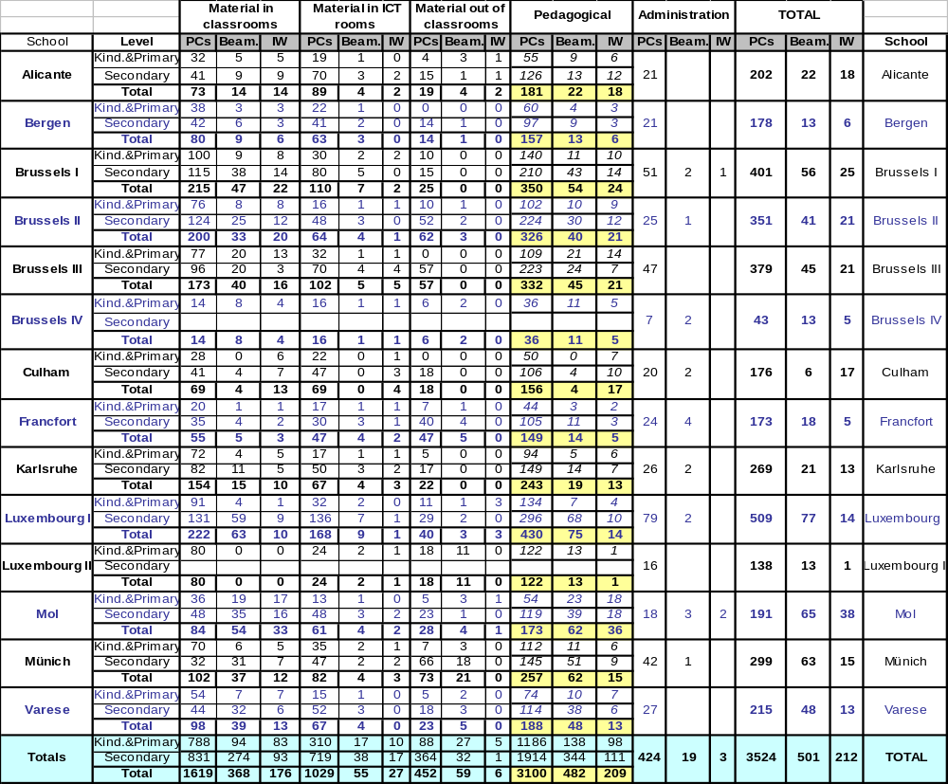
Table 1 ICT inventory by 31/12/2007
From the table 1 we can see that around one half of the computers are located on classrooms and one third at ICT rooms.
Mostly all the PCs at the classrooms are only used by the teachers, as a presentation device. The PCs at the ICT rooms are normally only accessible for ICT lessons, so, even if the figures look very high we can conclude that there are no that many computers for the use of the pupils.
Virtually all students have a PC at home connected to the internet, and they are normally used for gaming, communicating and even learning. The ICT Steering Committee have discussed several times the idea of making a pilot project where all pupils of a class would have a small laptop computer that could be carried from one classroom to the other; with this approach the schools will be only in charge of providing a good internet wireless connection infrastructure, and the pupils will bring the material themselves. Nowadays such a project could be possible, as there is now some laptop PCs at the market under 300 euros.
Table 2 (ICT equipment ratios) show the ratios per pupil (number of pupils per PC, beamer or interactive whiteboard). These ratios might give wrong information, and in fact the new ICT plan does not make any use of them, as the targeted number of pupils per PC depends on more complex measures such as the size of the teaching courses, number of classrooms, complexity of the campus, etc. Small schools with small groups will always have a lower number of pupils per PC, in the same way that the ratio pupil per teacher is also lower on small schools.
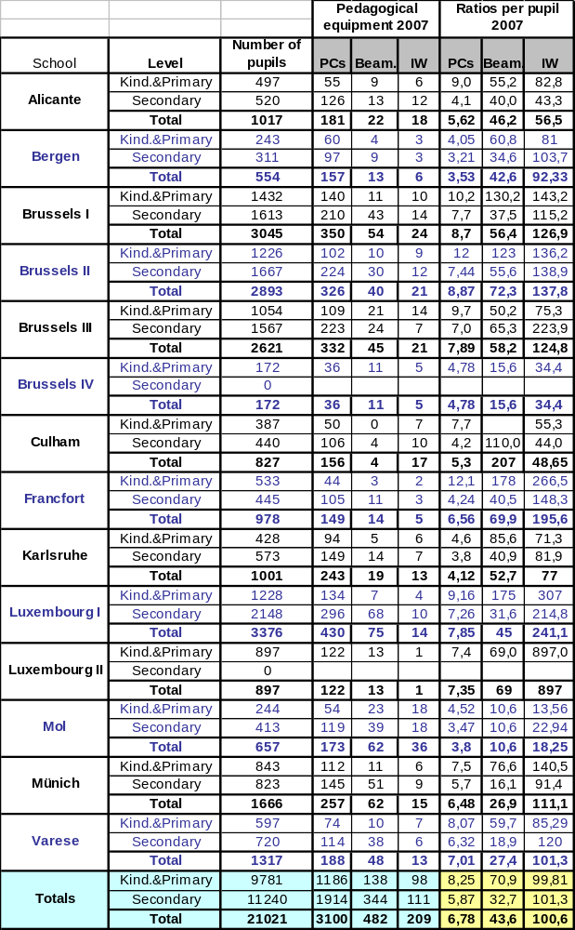
Table 2 ICT equipment ratios

The average ratio pupils per PC is 6,8 the ratio pupils per beamer is 43,6 and the ratio pupil per interactive whiteboard is 100,6.
Table 3 (Schools sorted by pupil/Pc ratio) shows the schools according to its pupil per PC ratio. Not surprisingly, the lowest ratios are on Bergen, Mol and Karlsruhe (all three are small schools) and the biggest ratios are in Brussels I, Brussels II and Luxembourg I (which are the biggest schools three times as bigger as the small schools)

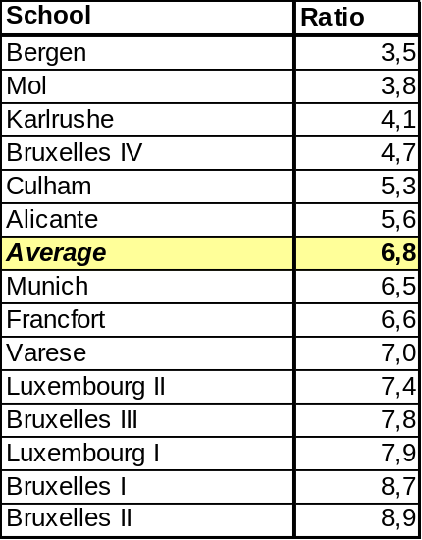
Table 3 Schools sorted by pupil/Pc ratio
Table 4 (evolution of the pupil/PC ratio) shows the evolution of the pupil per PC ratio in the last three years. The global figures show that the ratio pupil per PC is getting down, and this is a clear indicator that the computerization process is progressing.
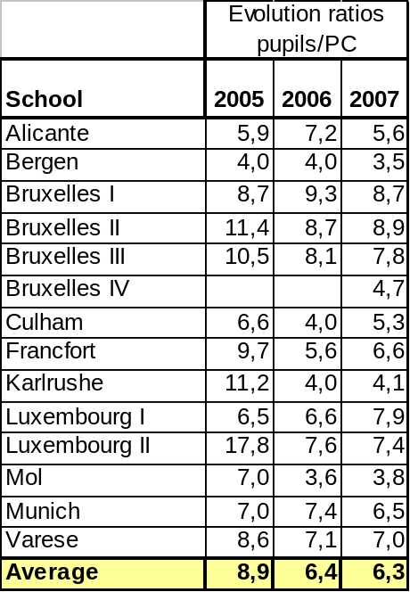
Table 4 Evolution of the pupil/PC ratio
Finally, Table 5 shows the progress according to the ICT Plan. The new ICT Plan made a multi-annual plan that had the strategy to scale the acquisitions in a period of 5 years in order that all schools could reach the same level of computerization by the year 2012. The table show us the expected evolution for the coming years, and all the schools are doing their best in order to progress according this plan.
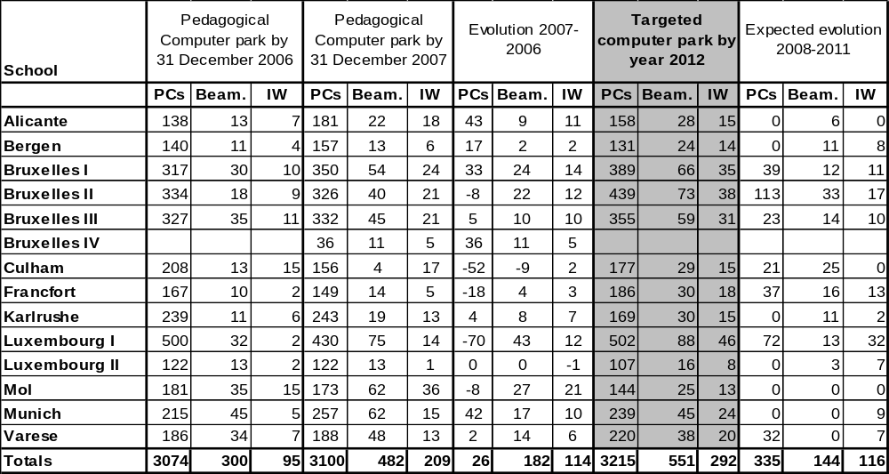
Table 5 Progress of the ICT Plan

