Schola Europaea

Office of the Secretary-General

Ref.: 2018-09-D-29-en-3
Original: EN

Mid-Term Report of the Educational Adviser Working Group
Board of Governors
Meeting on 4 to 7 December 2018 – Brussels

- Introduction

The Working Group on Continuous Professional Development/Evaluation started in 2016 to discuss the role and duties of the Educational Adviser and the Principal Educational Advisor.
In this context it became obvious that the current roles, responsibilities and tasks of the Educational Adviser are not clearly set and differ quite often within one school and from school to school. The members of the Working Group concluded that the current profile and working standards might then need further clarification. Such clarification would be needed to set up a policy of continuous professional development of Educational Advisers.
In its discussions the CPD/Evaluation Working Group included some signals from schools that they might have different needs regarding this function and considered the shift in the original role/tasks of the Educational Adviser, mainly due to the digitalisation of administrative tasks and evolution of the System. Those administrative tasks (e.g. collecting and registration of absences) were quite time-consuming and have considerably evolved. The use of the digital platforms and other digital tools as well as e-mail and short message texts for communication require other tasks and different competences.
Finally, the Board of Governors was asked to set up a Working Group dealing with the profile and tasks of the Educational Adviser and the Principal Educational Adviser.

At its meeting in December 2016 the Board of Governors decided to
- give a mandate to a new working group, whose remit would be a project to define the profile of the function of Educational Adviser and Principal Educational Adviser, taking account of possible changes to the future organisation of the schools.

- The mandate should cover:
- An analysis based on the survey conducted by the ‘CPD’ Working Group, revision and clear definition of the profiles of Educational Adviser and Principal Educational Adviser.
- This definition should clarify the duties and the profile of (Principal) Educational Advisers and, if necessary, adapt them to match the requirements.
- Engaging in reflection on the possibility that the future function of Educational Adviser might also meet the needs of the nursery and primary cycles.

- By taking account of the experience of the members of the ‘Continuous Professional Development’ Working Group this new Working Group should be composed of one representative of:
- the Directors,
- the Deputy Directors for the nursery and primary cycle,
- the Deputy Directors for the secondary cycle,
- the Staff Committee,
- Interparents,
- the Directors of the Accredited Schools (at their expense) and
- the Commission.
Moreover, it is left to the Working Group to decide as to whether or not it is advisable to invite an Educational Adviser also to participate in its work.
- Finally, the Working Group should set an agenda for the start and finalisation of its work.

- Scope of the mandate
The mandate given by the Board of Governors was quite clear. Nevertheless, some areas for discussion are not directly addressed in the mandate. This concerns for example the status of Educational Advisor and Principal Educational Adviser. For the time being a reference can be found in the Regulations for Seconded Staff Members of the European Schools, but not in the Service Regulations for Locally Recruited Teachers in the European Schools.
Another aspect of practical relevance is the question of staff representation and the discharge of Educational Adviser and Principal Educational Adviser in case they are elected as representatives of the teaching staff.

The Regulations for Seconded Staff of the European Schools make in Article 6 lit. b) a distinction between
- Principal educational adviser,
- Educational adviser with a teaching qualification and
- Educational adviser holding a secondary school certificate and without teaching qualifications.
According to their different tasks/qualification their remuneration varies between scale 4 and scale 9.
Article 36.5 of the Regulations for Seconded Staff fixes that Principal Educational Adviser and Educational Adviser should follow a 40-hour-week.
A clear description of their tasks and duties is not fixed in the staff regulations.
But there is a short description of the tasks of the Principal Educational Adviser and the Educational Adviser in Article 27 of the General Rules of the European Schools (see the text of Article 27 in the Annex of this document).
A survey launched by the Continuous Professional Development Working Group gave a very heterogeneous picture of the current tasks of the Principal Educational Advisers and the Educational Advisers.
The majority of Educational Adviser seem in line with Article 27 of the General Rules
- to carry out supervision,
- are involved in the maintenance of order and discipline,
- are monitoring pupils and
- provide administrative assistance.
Nevertheless, the percentage linked to each task varies among Educational Advisers at the same school and between the different schools.

Article 36.5 of the Regulations for Seconded Staff Members also rules out the conditions under which a Principal Educational Adviser or an Educational Adviser might be required to teach lessons.

- Work in progress

The Educational Adviser Working Group met since November 2017 six times and addressed in these meetings:
- the general needs of the schools,
- the potential structure of an ‘advisory team’,
- the potential role of the head of this team and the creation of a new function of ‘Assistant to the Deputy Director’ (replacing the current function of Principal Educational Adviser) and
- the appointment procedure for such a new function.

- General needs of the schools

The Working Group tried to take in consideration the needs of the schools in the pedagogical and administrative area and tried to develop based on these needs the potential structure of an ‘advisory team’ which would cover
- the current tasks carried out by Educational Adviser and Principal Educational Adviser in the schools and
- addresses also the need of the current management to receive support in the pedagogical and administrative area (idea of ‘middle management’).

The needs of the schools are illustrated in the following graphic:
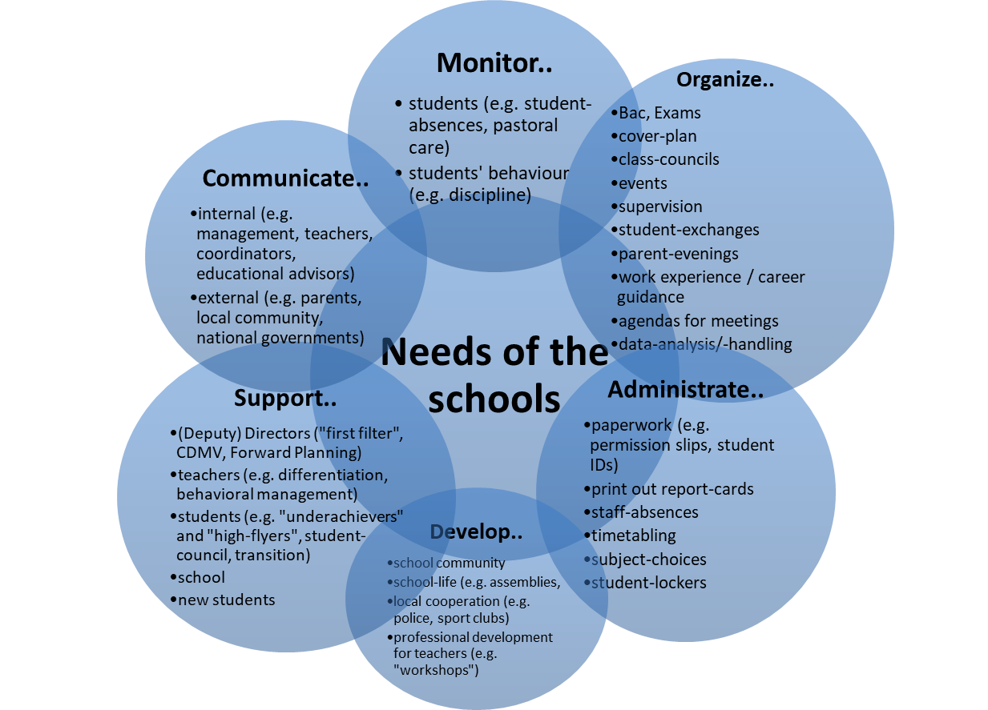

- Structure of the Advisory Team

Based on these needs the members of the Working Group considered that in each school an ‘advisory team’ should be established. The number of the team members should depend on the size of the individual school.
The lead of the team would be taken by one of the two future ‘Assistants to the Deputy Director’. The current function of Principal Educational Adviser would be covered by this new ‘team leader’.

“School-Advisory-Team”

Aim of the team: is the well-being of students in the broadest context and support of the management of the school.
Cluster of tasks: should fit into the needs of the schools (see diagram above)
“Team-approach”: Experts at different levels to cover the tasks. Set-up of team according to strengths and competences of the team-members. The tasks can be split up amongst the team (possible responsibility of the Head of EAs). The whole team has the “helicopter-view” and can take over tasks of other team-members.

Different functions/levels and qualifications within the team: (see diagram below)
- Head of EAs
Coordinating competences, Managerial competences, pedagogical/didactical content
- EA
Social/communicative skills, problem-solving-skills, pedagogical/didactical content
- Secretary
Fantastic administrative-/ICT-skills

Depending on the size of the school, a team could be composed of different staff-members (mathematical ratio to be defined; see table below for examples).

Examples:

The ratio for a large school could be something like this: | The ratio for a small school could be something like this:
1 Assistant to the Deputy Director per cycle (one of them being also the Head of EAs)  6-8 EAs (together: expertise from nursery to the Bac)  1 Secretary | 1 Assistant to the Deputy Director per cycle (but in primary with additional teaching obligations) (one of them being also the Head of EAs)  3-5 EAs (together: expertise from nursery to the Bac)  0,5 Secretary (part-time)

- Profiles and duties of the team members

Three different job-descriptions have to be designed.
They will have to address different requirements in terms of pedagogical/didactical qualification on the one hand side and administrative/organizational qualification on the other side (see diagram below for further explanation).

Pedagogical/Didactical qualification

Secretary
EA
Head of EAs

Administrative/Organizational qualification

- Profile and duties and appointment procedure for Assistant to the Deputy Director

3.a.1) Profile and duties

For the time being the Working Group focused on the profile and duties of the team leader/Assistant to the Deputy Director and the appointment procedure for such a ‘middle management’ function.
The members of the Working Group agreed that this new function will require strong pedagogical skills, but also managerial skills.
In general, in each school in each cycle an Assistant to the Deputy Director should be foreseen. Nevertheless, in the nursery/primary cycle in smaller schools the assistant should also have teaching obligations (for example 12 hours/week).
In the annex of this document a job description for the Assistant in the nursery/primary and the Assistant in the secondary cycle can be found.

3.a.2) Appointment procedure

The members of the Working Group analysed the current situation in the schools and discussed the question who should be eligible to the new function of middle management under which conditions.

- Current situation
Currently, the function of the pedagogical executive staff in the Schools (Directors and Deputy Directors Nursery/Primary and Secondary Cycle) are limited to seconded staff.
The nomination and selection process is laid down in ‘Implementing Regulations for the Appointment and Evaluation of Directors and Deputy Directors of the European Schools’ (doc. 2009-D-422-en-5).
On the contrary, there is no particular appointment procedure foreseen for the Principal Educational Advisor (nor for the Educational Advisor).
They are preselected by Member States and seconded to the schools like other teaching staff.
The function is foreseen for seconded staff; so far there is no locally recruited Principal Advisor in the system of the European Schools.

- Possible concept
If the current function of a Principal Educational Advisor will be developed to an executive function (‘Assistant to the Deputy Director’), at least three questions need to be addressed:
- Should such a function be open for locally recruited staff?
- How should the nomination and selection procedure look like?
- Should the function be timely limited?
In particular, the first two questions are very much linked. If the function is open for locally recruited staff, the role of the Member States would differ from the one foreseen in the Rules for Appointment of Directors and Deputy Directors Nursery/Primary and Secondary Cycle.
The members of the Educational Advisor Working Group agreed on the following concept.

- Eligibility - Who could apply?
The members of the Working Group acknowledged that
- Member States are already facing problems to second qualified staff and that
- European Schools face problems to retain qualified locally recruited teachers also due to a lack of career opportunities.
For these reasons the members of the Working Group agreed that this function should in general also be open for locally recruited teachers. Nevertheless, priority should be given to seconded candidates.
In case no qualified candidatures for secondment will be received, the school will publish the post locally and will open it for locally recruited teachers as well. A similar concept exists for the function of Deputy Director for Finance and Administration.
It remains to be decided whether to locally recruited teachers already in the system priority should be given vis-à-vis external candidates. One option could be to publish the post internally in the system of the European Schools.

- How long will be the ‘mandate’?
The members of the Working Group agreed that the function should be timely limited to nine years like this is the case for other functions in the system of the European Schools. Previous years of secondment for another function should not be taken in consideration when calculating the nine years.
A transfer to another school should be possible only in the fifth year. In this case the total length of the mandate could be prolonged by one year to a maximum of ten years (five plus five).
An evaluation should be foreseen in the second and in the fifth year like for other executive functions.
The evaluation should be carried out by the Director and the national inspector in case of secondment. In case of an appointment of a locally recruited teacher the evaluation should be carried out by the Director and an inspector, who does not necessarily must have the same nationality as the locally recruited teacher.
In case of an appointment of a locally recruited teacher a derogation from the current Service Regulations for Locally Recruited Teachers will be needed, as these Service Regulations only foresee initial contracts of a determined period of two or three years.
In case of an appointment of a locally recruited teacher the contract should foresee a duration of five years with an option of a further prolongation of four years.
Obviously, the post should also be open for locally recruited teachers already in the system. In this case the mandate should also be limited to nine years. If the candidate has already an unlimited contract as a teacher, he/she may come back to the teaching function after the end of his/her mandate.
Whether a second mandate as Assistant will be possible, will need further discussion. At least a second mandate at the same school should be excluded.

- What should be the selection and appointment procedure?
Concerning the appointment and selection process the members of the Working Group agreed that – different from the functions of Directors and Deputy Directors – not any kind of quota or other restrictions. These members of the middle management might have the same nationality as another member of the executive staff, the successor may have the same nationality as the predecessor etc.
In conclusion, this means that the nationality of the candidates will have no impact on the eligibility for the function.
Moreover, the members of the Working Group agreed to foresee a decentralized selection procedure in the school. Nevertheless, besides the management of the school (Director and deputy Director of the cycle concerned) also an inspector should be involved in the selection procedure. He/she should not have the same nationality as one of the candidates. A member of the teaching staff committee of the school should participate with the status of an observer.

- Salary conditions
Currently, Principal Educational Adviser receive a salary provided by scale 5 of the ‘Salary Scale for Members of the Seconded Staff of the European Schools’.
Deputy Directors Secondary Cycle are linked to scale 2 and Deputy Directors for the Nursery and Primary Cycle are linked to scale 3 (for the details see the annex 2 of this document).
In line with the ongoing discussion in the Working Group it is proposed to foresee the future function of ‘Assistant to the Deputy Director’ in both cycles.
In consequence, also two different salary scales could be foreseen. One linked to the Assistant to the Deputy Director Primary and Nursery Cycle and one linked to the Assistant to the Deputy Director for the Secondary Cycle.
Depending on the requested final profile this could be scale 3 for the secondary cycle and scale 4 for the nursery/primary cycle.
An alternative would be to link this temporary function to a temporary allowance.
For locally recruited teachers filling these posts of middle management a new salary scale or a temporary allowance needs to be developed.
Moreover, the working hours (40 hours/week) would need to be fixed in the Service Regulations for Locally Recruited Teachers.

- Conclusions of the Joint Teaching Committee

The Joint Teaching Committee appreciated the fact that in the report, the necessity of a middle management, both in Nursery-Primary and Secondary, had been recognised. The JTC expressed a favourable opinion on the mid-term report and the propositions elaborated by the Educational Advisers WG. The document would be forwarded to the Budgetary Committee and then to the Board of Governors for opinion.

- Conclusions of the Budgetary Committee
The Budgetary Committee supported the mid-term report of the Educational Adviser Working Group and ask to include a fianancial statement in the final report.

- Proposal
The members of the Board of Governors are invited to express an opinion on the mid-term report and the proposals elaborated by the WG “Educational Advisers”.
Based on the feedback of the Boad of Governors the Working Group will continue its work by addressing also the profile and duties of the other members of the advisory teams.

Annex 1

Assistant of Deputy Director – Nursery and Primary Cycle

Main responsibilities:
- The role of the Assistant of the Deputy Head (ADH) is to work closely with the N/P Deputy Head (DH) and to have an understanding and to be able to take responsibilities in following areas with prior delegation of the DH:
    - Responsible for the N/P school by delegation of duties in the areas of pedagogy and administration (including specific budget issues).

5 key areas:

- Well-being, behaviour and discipline.
- Organisation of studies.
- Recruitment and the evaluation of pedagogical staff.
- Implementation and development of planning, policies/documents and guidelines.
- Communication to parents, teachers, students and other stakeholders.

While the core function and key areas are the same in all schools, the schools should have some autonomy concerning all parts of the job description, e.g. with respect to the list of possible tasks from the list below.

List of possible tasks in consultation with the Deputy Director Nursery and Primary Cycle:

- In the event when the DH is absent, the ADH acts as the back-up. (1) – (5)
- Coordinates the well-being of pupils, is part of the Care-team and Discipline management team. Administration of incidents, liaising with all parties (pupil, teacher, supervisors, parents, psychologist, nurses, management). Follow-up and record keeping. (1)
- Promotes an inclusive environment. (1), (4), (5)
- Is involved in the development and implementation of the school’s philosophy and annual/ multi-annual plan. (1), (4), (5)
- Promotes the team spirit across the Nursery and Primary school. (1), (5)
- Liaises section and level coordinators to ensure harmonisation and structuring across sections. (2)
- Organises and supervises timetables for teachers. (2)
- Involvement in the organisation of languages tests in accordance with Article 47 e). (2) - (4)
- Supports mentors and provides support to coordinators and teachers in sharing good practice. (2) - (4)
- Chairs and attends meetings and working groups and shares necessary information to other members of teaching staff. (2) – (5)
- Assists in the induction of new staff into the school. (3)
- Supports Continuous Professional Development and ongoing educational developments, e.g. through Action Plans, scheduling peer-observation, organization and cooperation with internal and external experts and trainers. (4)
- Monitors that all annual and periodic planning is available on due time. (4)
- Monitors Transition. (4) – (5)

Qualifications/ Professional Experience:

- Experienced in one or more pedagogical function(s)

- Managerial skills
- Form/ lead a team
- In-Service-Training abilities
- Assertiveness
- Empathy

- Teaching qualification and experience

- Language skills (at least the two main languages of the school)

- Communication skills
- Parents
- Pupils
- Members of staff

- Work-experience in an International/ European School environment would be an asset.

Assistant of Deputy Director – Secondary Cycle

Main responsibilities:
- The role of the Assistant of the Deputy Head (ADH) is to work closely with the Secondary Deputy Head (DH) and to have an understanding and to be able to take responsibilities in following areas with prior delegation of the DH:
    - Responsible for the secondary school by delegation of duties in the areas of pedagogy and administration (including specific budget issues).
- Coordinates the ‘Advisory Team’ in the school.

5 key areas:

- Well-being, behaviour and discipline.
- Organisation of studies and Examinations for S4-S7.
- Recruitment and the evaluation of pedagogical staff.
- Implementation and development of planning, policies/documents and guidelines.
- Communication to parents, teachers, students and other stakeholders.

While the core function and key areas are the same in all schools, the schools should have some autonomy concerning all parts of the job description, e.g. with respect to the list of possible tasks from the list below.

List of possible tasks in consultation with the Deputy Secondary Cycle:

- In the event when the DH is absent, the ADH acts as the back-up. (1) – (5)
- Coordinates the well-being of pupils, is part of the Care-team and Discipline management team. Administration of incidents, liaising with all parties (pupil, teacher, supervisors, parents, psychologist, nurses, management). Follow-up and record keeping. (1)
- Promotes the team spirit across the Secondary school. (1), (5)
- Is involved in the development and implementation of the school’s philosophy and annual/ multi-annual plan. (1), (4), (5)
- Organises and coordinates the S4-S7 exams. (2)
- Involvement in the organisation of languages tests in accordance with Article 47 e). (2)

- Liaises with coordinators to ensure harmonisation and cooperation across sections. (2), (4)
- Organises and supervises replacement for teachers. (2)
- Supports, mentors and provides support to coordinators and teachers in sharing good practice. (2), (4)
- Chairs and attends meetings and working groups and shares necessary information to other members of teaching staff. (2), (5)
- Assists in the induction of new staff into the school system. (3)
- Supports Continuous Professional Development and ongoing educational developments, e.g. through Action Plans, monitoring peer-observations, organization and cooperation with internal and external experts and trainers. (4)
- Monitoring of the follow-up of the implementation of new syllabuses in cooperation with the subject-referents. (4)
- Monitors that all annual and periodic planning is available on due time. (4), (5)
- Monitors Transition. (4), (5)
- Coordinates the student's participation having the responsibility of organizing the pupil's committee and the follow-ups (5)

Qualifications/ Professional Experience:

- Experienced in one or more pedagogical function(s)

- Managerial skills
- Form/ lead a team
- In-Service-Training abilities
- Assertiveness
- Empathy

- Teaching qualification and experience

- Language skills (at least the two main languages of the school)

- Communication skills
- Parents
- Pupils
- Members of staff

- Work-experience in an International/ European School environment would be an asset.

Annex 2

CURRENT SALARY SCALES FOR MEMBERS OF THE SECONDED STAFF OF THE EUROPEAN SCHOOLS

Scale 1
Director
Deputy Secretary-General
Scale 2
Deputy Director for the secondary cycle
Senior Assistant to the Secretary-General in charge of an administrative unit
Central Accounting Officer
Financial Controller
Head of an administrative unit
Scale 3
Secondary school teacher
Deputy Director for the nursery and primary cycle
Deputy Director for Finance and Administration
Scale 4
Administrative and Legal Officer
Scale 5
Principal educational advisor
Scale 6
Teacher qualified to teach lower secondary classes only
Assistant Financial Controller
Scale 7
Primary school teacher
Nursery school teacher
Educational advisor with a teaching qualification
Librarian
Scale 8
Scale 9
Educational advisor with a secondary school leaving certificate but without teaching qualifications

