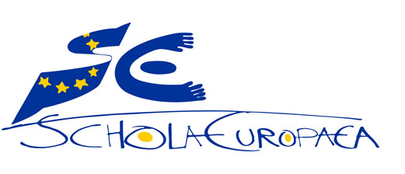 | European Schools  Office of the Secretary-General

Ref.: 2017-09-D-42-en-2
Orig.: FR

Mondorf-les-Bains International School: General Interest File
BOARD OF GOVERNORS
Meeting on December 5-7, 2017 – Brussels

Luxembourg, 18 September 2017

THE GOVERNMENT
OF THE GRAND DUCHY OF LUXEMBOURG
Ministry of Education, Childhood and Youth

Secondary Education Department – VR
Tel.: 247-85131 Fax: 247-85129
viviane.rhein@men.lu The Secretary-General of the
European Schools
23, rue de la Science

B-1040 BRUSSELS

Dear Sir,

With the aim of widening, diversifying and making more flexible the range of state (public sector) schooling offered in the Grand Duchy of Luxembourg, and in view of the huge success of the Differdange and Esch/Alzette International School, I intend to extend the range of state European schooling offered in the Grand Duchy of Luxembourg. It is the State’s responsibility to offer a state education system in which each pupil has a chance to succeed, irrespective of the language spoken at home.

Over and above efforts to integrate foreign pupils who will remain in the country, the offer of new international schools matches the needs of children and teenagers residing temporarily in the Grand Duchy and set to continue their education in another country.

A high-quality schooling offer is an important factor in the decision of a company, a foreign investor or scientific experts as to whether or not to move to Luxembourg. That is why I find it important for international schools to be set up in geographical areas of the country from which pupils cannot easily access the International School at Differdange and Esch, which is located in the south of the country.

I am therefore taking the liberty of appending hereto three general interest files concerning the setting up of three International Schools which will operate as Accredited European Schools. Linked to the European School system by an accreditation agreement, they will offer an education based on the European Schools’ curricula. The education provided will lead to the European Baccalaureate. The Luxembourg Ministry of Education will take responsibility for their administration, funding and staff in their entirety.

These three European schools, which will be located in the centre-east, the north and the south- east of the country respectively, are intended to provide a response to the growing heterogeneity of the Luxembourg pupil population. They will also target the inhabitants of those regions who do not necessarily have previous multilingual experience but who wish to offer their children a varied linguistic and cultural education. They will be operational as from the beginning of the 2018-2019 school year.

Junglinster International School, an Accredited European School located in the centre-east of the country, near Luxembourg-City and Luxembourg Airport, will operate with two language sections, an English section and a German section.
- Edward Steichen International School, an Accredited European School at Clervaux, located in the Luxembourg Ardennes in the north of the country, will operate with two language sections, a French section and a German section.
- Mondorf-les-Bains International School, an Accredited European School at Mondorf-les-Bains, the town which hosted the meeting of the Board of Governors under the Luxembourg presidency in April 2005, will operate with three language sections, an English section, a French section and a German section.
I would request you to submit the three general interest files appended hereto to the Joint Board of Inspectors at its forthcoming meeting on 11 October 2017.
I remain at your disposal should you have any questions concerning this matter.
Yours faithfully,
(signature)

Claude MEISCH
Minister of Education,
Childhood and Youth

General Interest File

Mondorf-les-Bains International School – Accredited European School
(Grand Duchy of Luxembourg)

Contents
Mondorf-les-Bains International School: General Interest File 1
Introduction 6
European schooling offered in Luxembourg 6
Diversification of the range of schooling offered in Luxembourg 7
Totals of the population of the European Schools in Luxembourg and of the pupil population in Luxembourg 9
European schooling in Luxembourg 9
National primary education in Luxembourg 9
National secondary education in Luxembourg 10
Pupil population in the south east of Luxembourg 11
Mondorf-les-Bains International School as an Accredited European School 12
Operation of Mondorf-les-Bains International School – Accredited European School 14
Supervision, pastoral care and monitoring of pupils 15

Introduction

After the signing in 1952 of the Treaty establishing the European Coal and Steel Community (ECSC), which was to start the process of European integration, European leaders quickly came to realise that the mobility of officials and other staff of the European institutions required specific schooling provision to be put in place for their children, and first and foremost tuition in their mother tongue, which could follow on from the education which they had received hitherto in their country.
Thus it was that the European School system came into being in 1953 and that the first classes were set up at Luxembourg-Limpertsberg. To date, 14 European Schools across Europe are attended by some 27 000 pupils and 13 Accredited European Schools supplement the European schooling offer.
Whilst mobility in Europe was initially limited to just a few people, liberalisation of the travel and employment provisions in the EU, the introduction of the Schengen area and, above all, the increased mobility of young people through exchange and training programmes within the EU, such as Erasmus, Leonardo da Vinci and Grundtvig, were instrumental in this mobility’s having become available to all nowadays. Increasing numbers of Europeans are daring to look beyond the borders of their country of birth and discovering new living and working environments, this mobility being a guarantor for the personal development of young people and employees to the same degree as it represents a gain in terms of quality and of exchange of experience and of practice for businesses.
Now these employees and young people are going to take their mother tongue abroad and it is fairly likely that they are going to educate their children in that language. It is self-evident that in a Europe that is in the process of unification and of reshaping of its identity, children should not be overlooked. If diversity is our continent’s source of richness, it needs to be cultivated. From the educational viewpoint, whilst we are gradually coming to understand that there are no means of training our young people for jobs of which we are unable as yet to conceive, the Copernican Revolution will involve discovering and promoting everyone’s competences and skills so that they can find element in they which they will be able to develop, flourish and make a success of their lives.
That is why the linguistic aspect is important as soon as children first go to school; the language in which they become literate is not insignificant and, in a multilingual context, nor is the vehicular language used in lessons.
Because of the emphasis placed by the European School system on the flexibility and diversification of language learning, on multilingualism and on the highlighting of mother tongue, it meets the demands of today’s Europeans.
With that in mind, Luxembourg intends to widen what it has to offer and to add an additional European School with the status of Accredited European School to its state schooling range in 2018.

European schooling offered in Luxembourg

Today, Luxembourg has two European Schools, Luxembourg I, located at Luxembourg-Kirchberg, and Luxembourg II, located at Mamer. At this point in time, those two schools are about to reach their respective maximum capacity.
With the aim of extending the range of Francophone and Anglophone classes offered in Luxembourg, the Minister of Education, Childhood and Youth, Mr Claude Meisch, and the Secretary-General of the Board of Governors of the European Schools, Mr Kari Kivinen, signed an agreement in 2014 to increase the capacity of the Francophone and Anglophone sections in Luxembourg. Thus, as from the beginning of the 2014-2015 school year, some 100 additional places were available in those sections and were open to pupils whose parents did not work for the European institutions. The Luxembourg State contributes to the funding of those additional classes, enabling so-called category 3 pupils to be admitted to the European School in Luxembourg, whilst reducing their school fees to 40%. In 2016, the opening of the Differdange International School with the status of Accredited European School proved to be an immediate success and demand is far from being met.
This is attributable to the fact that because of EU enlargement, the number of EU officials and other staff is steadily growing; at the same time, the imminent changes, resulting from Brexit in particular, are leading quite a large number of multinational companies to set up their registered office in Luxembourg and the population is becoming increasingly international.
Increasing capacity in the Francophone and Anglophone sections and setting up the Differdange International School were the first steps in the Luxembourg Government’s endeavours to diversify the range of schooling and to offer a high-quality education in different languages, so as to cater for the growing heterogeneity of the pupil population.

Diversification of the range of schooling offered in Luxembourg

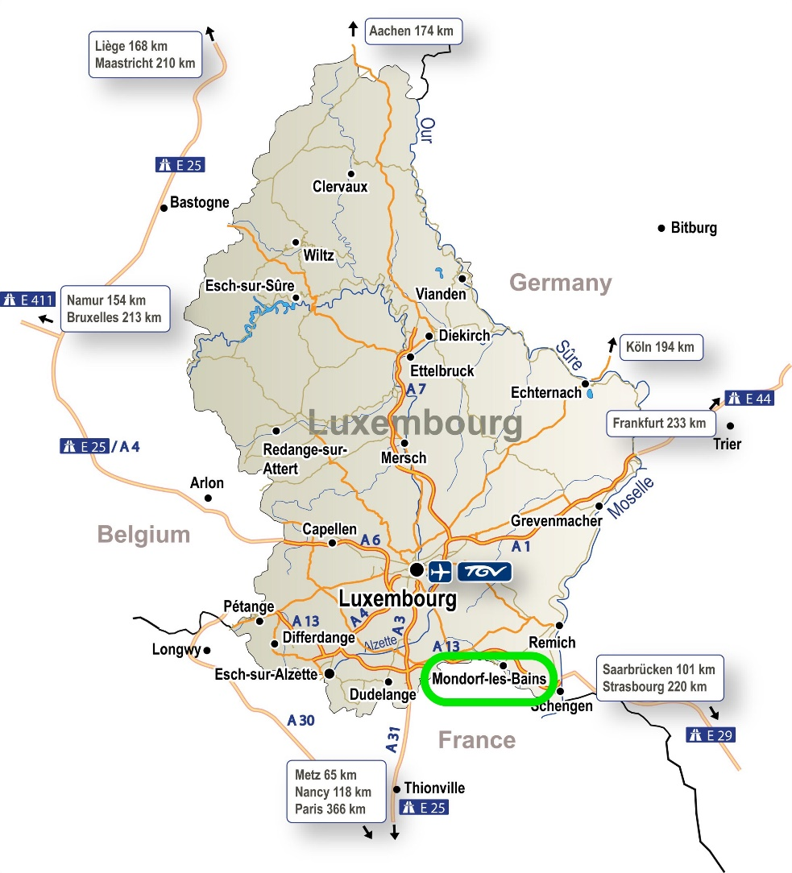
With a view to increasing and diversifying the range of state schooling offered, the Luxembourg Government intends to set up an International School at Mondorf-les-Bains in the south east of the country. The municipality, with a population of around 5000, is located in a region characterised by relatively poor provision of schooling possibilities. This situation has only been partially remedied by the opening of the Deutsch-Luxemburgisches Schengen-Lyzeum (German-Luxembourg Schengen Lycée) at Perl, with the result that most pupils still face accessibility problems in terms of all the other existing Lycées in the surrounding area, with journeys to and from school of over 30 minutes.
Located on the French border and 6 kilometres from the German border, Mondorf-les-Bains is alongside the A13 motorway which links Belgium and the Saarland and crosses the main road between Luxembourg and Thionville-Metz. Mondorf-les-Bains is part of a network of twinned municipalities consisting of five other European towns.
The main objective of the Mondorf-les-Bains International School – Accredited European School will be the introduction of an offer of schooling for the children and young people of Mondorf-les-Bains and of the south east of the country. The municipality is booming demographically and the establishment of international companies in the south of the country has resulted in the population’s becoming increasingly international. At that level, the decision of a company or of a foreign investor to set up or invest in Luxembourg is largely influenced by the presence of a high-quality schooling offer.
Whilst the aim of putting in place an international schooling offer is to provide a response to the challenge of an increasingly heterogeneous pupil population, it also enables the needs to be met of children from language communities which have been present in the country for longer. It is indeed the Government’s responsibility to offer a range of state education provision which allows each pupil to succeed according to his or her capabilities, irrespective of the language spoken at home. Offering a new international school therefore pursues a threefold aim: to ensure the integration of pupils of foreign origin, to provide schooling for young foreigners who are only temporarily resident in the Grand Duchy and are set to continue or indeed complete their education in another EU country and to promote a spirit of openness towards Europe amongst young Luxembourgers.

The proposed classes at the Mondorf-les-Bains International School – Accredited European School are additional to the current international offer, namely:
- the International Baccalaureate, Anglophone classes for which are offered at the Athénée de Luxembourg, and Francophone classes for which are offered at the Lycée technique du Centre,
- classes leading to the General Certificate of Secondary Education (GCSE) and to the A-level examinations offered at the Lycée Michel Lucius,
- the English and French language sections of the Luxembourg-Kirchberg and Mamer European Schools,
and supplement what is offered at the Differdange International School, whilst also extending it to the south east of the country.
The plan is for the Mondorf-les-Bains International School – Accredited European School to start operating on temporary premises set up on the Bei Gremelter site, where temporary buildings for the primary and the secondary will be constructed and completed for the beginning of the 2018-2019 school year in September 2018. Work on the permanent buildings is scheduled to be completed by the beginning of the 2021-2022 school year.

Totals of the population of the European Schools in Luxembourg and of the pupil population in Luxembourg

European schooling in Luxembourg
School | Cycle | 2012/13 | 2013/14 | 2014/15 | 2015/16 | 2016/17
Luxembourg I | Nursery | 413 | 382 | 448 | 461 | 444
 | Primary | 949 | 1042 | 1138 | 1226 | 1320
 | Secondary | 1353 | 1362 | 1386 | 1394 | 1496
Total Luxbg I |  | 2715  -24.14% | 2786  +2.6% | 2972  +6.7% | 3081  +3.7% | 3260  +5.8%
Luxembourg II | Nursery | 238 | 270 | 299 | 307 | 299
 | Primary | 708 | 773 | 842 | 916 | 1023
 | Secondary | 1019 | 1058 | 1102 | 1125 | 1209
Total Luxbg II |  | 1965  +105.33% | 2101  +6.9% | 2243  +6.8% | 2348  +4.7% | 2531  +7.8%
Grand total Luxbg |  | 4682  +3.2% | 4887  +4.4% | 5215  +6.7% | 5429  +4.1% | 5791  +6.7%
Total of the 14 European Schools |  | 23869 | 24547 | 25385 | 25903 | 26691

The above table, the figures in which are taken from the report of the Board of Governors of the European Schools on the facts and figures on the beginning of the 2016-2017 school year in the European Schools, shows that the population of the two European Schools in Luxembourg is increasingly significantly and steadily.

National primary education in Luxembourg
 | 2012/13 | 2013/14 | 2014/15 | 2015/16 | 2016/17
Total Luxembourg elementary education | 47608 | 47694 | 47145 | 47766 | 48495
National nursery education  Cycle 1 | 10740 | 10748 | 10948 | 11027 | 11008
of which foreigners | 47.4% | 47.2% | 46.5% | 45.7% | 45.5%
Nursery education  private and international schools | 1300 | 1321 | 1461 | 1540 | 1620
National primary education  Cycles 2-4 | 31975 | 31894 | 32152 | 32556 | 33107
of which foreigners | 50.0% | 50.3% | 50.4% | 46.1% | 46.2%
Primary education  private and international schools | 3275 | 3541 | 3768 | 4070 | 4356
1st language spoken at home
Lëtzebuergesch | 39.8% | 38.7% | 37.6% | 36.5% | 35.8%
Other | 60.2% | 61.3% | 62.3% | 63.5% | 64.2%

At the level of national primary education, the above table documents certain trends:
- Luxembourg society is becoming increasingly international. Whilst Lëtzebuergesch remains the most widely spoken language and the language of integration, it is now the first language spoken in only a third of families.
- Whilst the total number of pupils in nursery and primary education is increasing, the number of pupils on roll in the national education system remains roughly constant. On the other hand, demand for international schooling offers is going up.

National secondary education in Luxembourg
 | 2012/13 | 2013/14 | 2014/15 | 2015/16 | 2016/17
Total Luxembourg secondary education | 39585 | 39830 | 39653 | 39582 | 39314
Classical secondary education ESC  Upper and lower | 12958 | 12832 | 12501 | 12057 | 12022
of which foreigners | 20.0% | 21.3% | 21.6% | 21.8% | 20.7%
General secondary education ESG  Lower classes and technician’s regime | 19049 | 19555 | 19753 | 20017 | 19856
of which foreigners | 44.2% | 45.3% | 45.7 | 46.1% | 48.2%
1st language spoken at home
Lëtzebuergesch | 54.4% | 52.6% | 50.6% | 48.6% | 47.4%
Other | 45.6% | 47.4% | 49.4% | 51.4% | 52.6%

At the level of national secondary education, the above table documents the same trends as the primary education table, but there are others which should be taken seriously:
- the pupil population in classical secondary education is gradually declining;
- the pupil population in general secondary education is increasing;
- the percentage of foreign pupils in the Luxembourg education system is going up, but it is going up more markedly in ESG than in ESC;
- it results from the above finding that the already stark divide in the percentage of foreign pupils between ESC and ESG is continuing to widen;
- the percentage of pupils who speak a language other than Lëtzebuergesch as their first language at home is increasing markedly and constantly.

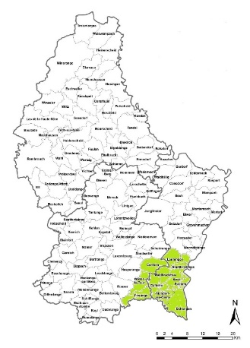
Pupil population in the south east of Luxembourg
The area in the immediate vicinity of the future Mondorf school comprises the municipalities of Bous, Contern, Dalheim, Frisange, Lenningen, Mondorf-les-Bains, Remich, Schengen, Stadtbredimus, Waldbredimus and Weiler-la-Tour.

The table below shows, by municipality, the numbers of pupils moving up from primary education to secondary education. As primary education is organised and managed by the municipalities and delivered on the territory of the municipalities, it is when they move up from the primary to the secondary that pupils have to choose the Lycée or other secondary school at which they are going to continue their education.

Municipality | 2012/13 | 2013/14 | 2014/15 | 2015/16 | 2016/17
Bous | 13 | 19 | 20 | 22 | 9
Contern | 32 | 30 | 39 | 34 | 26
Dalheim | 15 | 18 | 14 | 20 | 18
Frisange | 43 | 41 | 34 | 40 | 36
Lenningen | 20 | 31 | 35 | 17 | 36
Mondorf-les-Bains | 41 | 42 | 42 | 35 | 42
Remich | 33 | 33 | 32 | 38 | 22
Schengen | 36 | 50 | 34 | 43 | 46
Stadtbredimus | 13 | 18 | 14 | 22 | 13
Waldbredimus | 10 | 7 | 7 | 10 | 7
Weiler-la-Tour | 19 | 27 | 23 | 38 | 29
Total | 264 | 304 | 287 | 306 | 284

In the following table, the number of admissions to year 7 (12-year-olds) of secondary education in Luxembourg are shown for the three branches of secondary education, namely classical secondary education (ESC), general secondary education (ESG) and the preparatory pathway (VP), and for the four Lycées closest to Mondorf-les-Bains,
- to the east, the Deutsch-Luxemburgisches Schengen-Lyzeum at Perl (SLP; 13 km);
- to the west, the Lycée Nic Biver at Dudelange (LNB; 20 km);
- to the north west, the Lycée technique de Bonnevoie (LTB; 28 km);
- to the north east, the Maacher Lycée at Grevenmacher (MLG; 30 km).

School | Branch | 2012/13 | 2013/14 | 2014/15 | 2015/16 | 2016/17
SLP | ESC | 41 | 55 | 52 | 54 | 48
LNB | ESC | 56 | 61 | 48 | 61 | 54
 | ESG | 208 | 179 | 177 | 152 | 162
 | VP | 73 | 62 | 76 | 78 | 68
LNB total |  | 337 | 302 | 301 | 291 | 284
School | Branch | 2012/13 | 2013/14 | 2014/15 | 2015/16 | 2016/17
LTB | ESC | 123 | 111 | 110 | 82 | 91
 | VP | 24 | 33 | 35 | 32 | 31
LTB total |  | 147 | 144 | 145 | 114 | 122
MLG | ESC | 15 | 19 | 15 | 25 | 23
 | ESG | 103 | 99 | 80 | 104 | 84
 | VP | 24 | 24 | 24 | 32 | 25
MLG total |  | 142 | 142 | 119 | 161 | 132
Grand total |  | 626 | 588 | 565 | 566 | 538

The above table reveals that the number of admissions in year 7 has been constant, at most, for the two Lycées in the east of the country (SLP and MLG), whereas it has steadily declined over the last five years in the other two Lycées.
In a nutshell, the setting up of another traditional Lycée comprising the Luxembourg ESC and/or ESG is pointless at present. On the other hand, it seems imperative to offer an education allowing better integration into school of foreign children, or indeed children who do not speak Lëtzebuergesch as their first language.

Mondorf-les-Bains International School as an Accredited European School

The planned school at Mondorf-les-Bains will operate according to the principles and methods of an Accredited European School. It will be allied with the European School system by the accreditation agreement and will determine its educational offer on the basis of the European Schools’ curricula. This offer will be aimed at the European Baccalaureate at the end of S7 and hence access to the higher education offered in Luxembourg or abroad.
From the administrative and financial angle, the school will develop under the responsibility of Luxembourg’s Ministry of Education, at the level both of the administration and of the budget and the staff.
The system will essentially offer the nursery (early education), primary and secondary cycles of the European School system. In the nursery cycle, two classes are planned, one Francophone and one Anglophone; in the primary and secondary cycles, three classes will be offered. A priori, there will be a French language section, an English language section and a German language section.
At the end of the observation cycle of the secondary education level in the European system, i.e. after S3, pupils will be able to opt for training leading to the diplôme d’Etat luxembourgeois de l’éducateur (Luxembourg State teaching assistant diploma). This training is offered in accordance with the provisions of general secondary education in Luxembourg.
At the level of Luxembourg secondary education, it is also planned to offer a number of vocational training courses at Mondorf-les-Bains International School – Accredited European School. A priori, these training courses will be in the care and well-being areas and will be organised in accordance with the arrangements of the Luxembourg school system. At this level, close collaboration is envisaged with the Saarland and with the Deutsch-Luxemburgisches Schengen-Lyzeum at Perl.
Access to these training courses will also be ensured for pupils in the European system at the end of S3. The plan is for the first vocational training classes to be offered at the beginning of the 2021/2022 school year.
A three-year preparatory pathway will be offered in the lower secondary cycle, designed to prepare the pupils concerned for the European system, or even for a vocational training course.
Finally, an occupational integration class (IPDM) is planned to cater for pupils who have dropped out of school early or who are at risk of doing so and to prepare them to join one of the vocational training courses then offered at the School. This class will start at the same time as the vocational training classes, i.e. provisionally as from the beginning of the 2021-2022 school year.
The following diagram shows the stages of European and Luxembourg education at the nursery, primary and secondary levels up to the European Baccalaureate and the Luxembourg school leaving certificates (academic, technical and vocational).
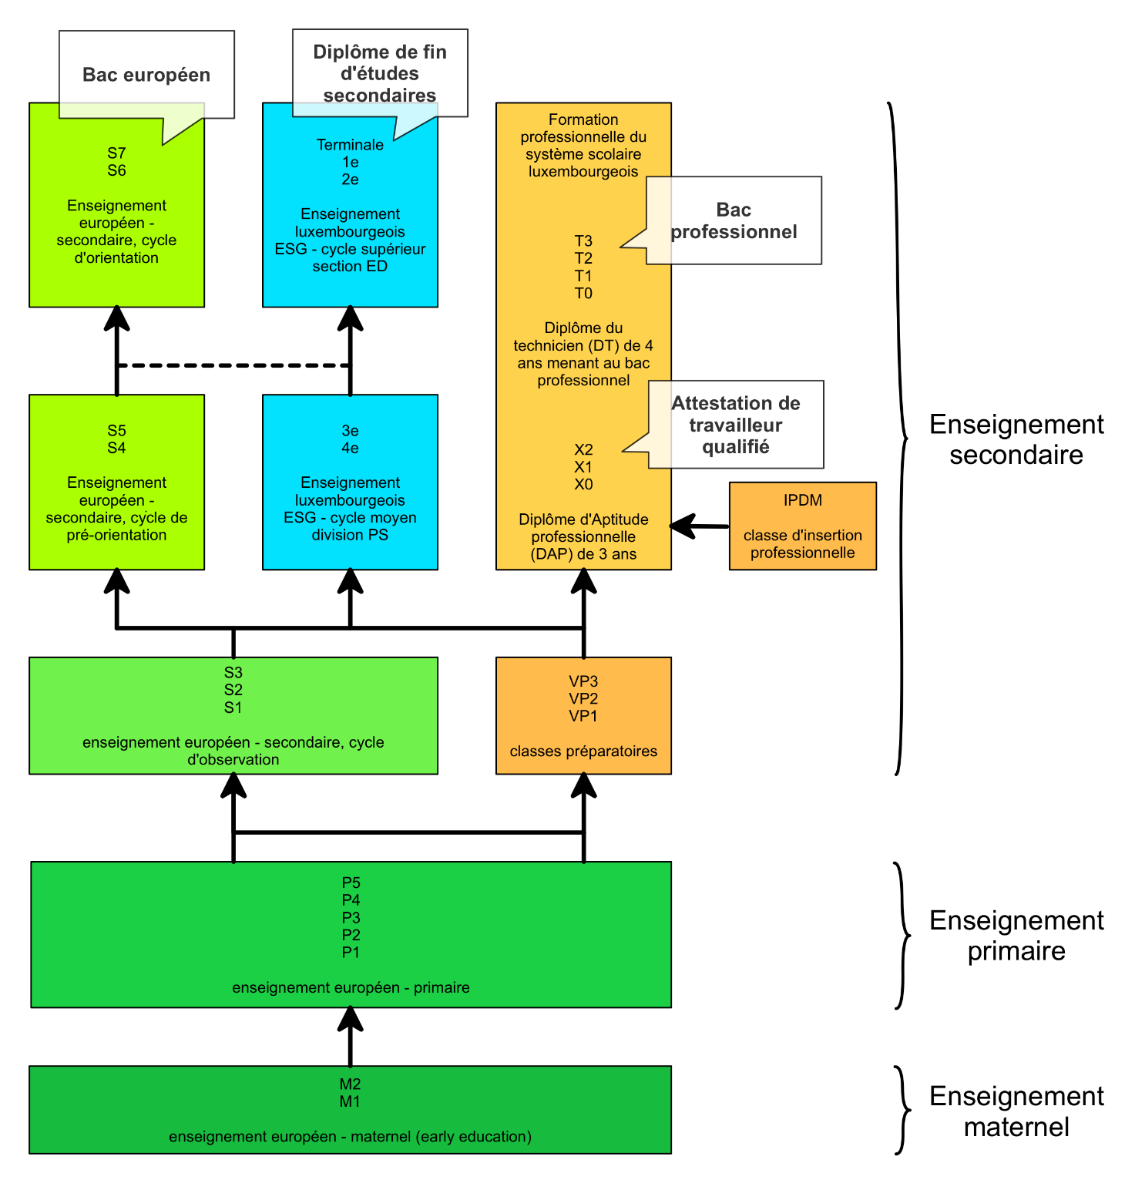
Specific reception arrangements will be put in place and offered for nursery, primary and secondary pupils. A team of qualified psycho-educational staff will offer this provision, which will cover the period between 7.30 and 18.00.
From the linguistic angle, primary school pupils will choose, in addition to the language of the section, another language – French, English, German or Portuguese. In P2, they will choose a third language from amongst those four languages. The learning of Lëtzebuergesch in turn will be compulsory for all primary school pupils and for pupils in the observation cycle of the secondary.
The plan is for the first classes to start at the beginning of the 2018-2019 school year in September 2018, in particular:
- three P1 classes in the primary;
- three S1 classes in the secondary;
- one preparatory class.
Once all the planned classes have been offered, the Mondorf-les-Bains International School – Accredited European School will have around 1400 pupils on roll.

Operation of Mondorf-les-Bains International School – Accredited European School

The Mondorf-les-Bains International School – Accredited European School will take as its basis the timetables and the assessment, promotion and certification methods of the European School system; it will participate within the European School network and will be subject to its quality control.
Should the number of applicants be larger than the number of places available, admission conditions will possibly need to be foreseen.
As far as the pedagogical freedoms provided for by the accreditation regulations allow, the school will use its autonomy to incorporate aspects of Luxembourg’s language, literature, history, geography and culture into its curricula.
In parallel with the European curriculum, the school will offer preparatory pathway classes to support children who, at the end of primary education, might not yet have reached the required standard of attainment in terms of basic skills to go into the observation cycle of the European schooling system. The preparatory pathway will therefore aim to ensure their readiness to join an observation cycle class. Alternatively, pupils who are keen to learn a trade will take advantage of the workshop courses in the preparatory classes to prepare for their vocational training. The preparatory pathway is largely defined by Luxembourg legislation on general secondary education but will be adapted, as far as the legal framework so allows, to the needs of the school and of the pupils.

Supervision, pastoral care and monitoring of pupils

The school’s management and council, grouping together the teachers and all the members of staff, will define, by the beginning of the first school year in September 2018, a first pedagogical project which will lay the foundations of the school’s identity. It is planned first of all to provide supervision before, between and after official school hours, broadly speaking from 7.30 to 18.00. Outside lessons, this provision will essentially comprise support or follow-up courses, remediation measures and scientific, cultural, craft and sporting activities. Beyond this, it is planned to encourage and to support other activities, according to the talents and interests shown by pupils.
An educational service, in collaboration with the teachers, will be responsible for:
- supervision of pupils outside lesson hours;
- assistance in the context of homework and possible remediation measures;
- monitoring of pupils;
- development of partnerships with local and regional associations at the scientific, cultural, craft and sporting levels;
- development of partnerships with businesses in the Greater Region with a view to entering into cooperation and to making available work experience sites and apprenticeship places;
- organisation and supervision of cultural and sporting activities;
- lesson replacement activities;
- extra-curricular activities.

To sum up, the plan is for the school to start up in September 2018 offering:
- three first classes at the primary level, including at least one English language class;
- three first classes at the secondary level, including at least one English language class and at least one German language class;
- one preparatory class.

The setting up of a school at Mondorf, on the Accredited European School model, will enable the Ministry of Education to meet the needs of an increasingly heterogeneous pupil population and to diversify the schooling offers landscape, so as to give each pupil a real and fair chance of success, irrespective of the language spoken in his or her family. As a result, school success will be conducive to the social integration of the young people who will shape the future of tomorrow’s Luxembourg society and of the European Union. In the end, in the case of all who leave Luxembourg during their schooling, the new school will have given them the knowledge and skills required to continue and complete their education in a different country.

OPINION OF THE JOINT BOARD OF INSPECTORS
The JBI expressed a favourable opinion on the General Interest File submitted by the Luxembourg authorities concerning the request for the setting up of an Accredited European School at Lycée Mondorf at Mondorf (GD of Luxembourg).
The JBI considered that this File met the requirements of the first stage of the accreditation process defined at Mondorf in April 2005 and recommended that the BoG should approve it.

For pupils in national secondary education, the figures for whom are shown in the following table, the relative position of Lëtzebuergesch remains higher in percentage terms, but is also subject to steady decline.
The figure does not include the 618 pupils enrolled in 2015-2016 in the international programmes offered in Luxembourg Lycées.
The figure does not include the 623 pupils enrolled in 2016-2017 in the international programmes offered in Luxembourg Lycées.

