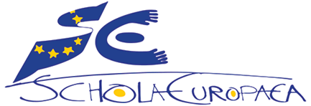 | Schola Europaea / Office of the Secretary General  General Secretariat
Ref.: 2019-10-D-40-en-5
Original: EN

Priorities of the Spanish Presidency of the European Schools 2019/2020 – 2.1 Reforms of the European Schools Curriculum

Board of Governors

Meeting on 15, 16 and 17 April 2020

Priorities of the Spanish Presidency of the European Schools 2019/2020
Ref.: 2019-10-D-40-en-5
Priority 2.1
Reform of the European Schools Curriculum.
Aim: Embed and strengthen the Key Competences for Lifelong Learning in the European Schools Curriculum

INTRODUCTION
Spain strongly believes in the essential role that the European Schools (ES) system plays in strengthening European identity among the young generations and endowing them with a better understanding of what it means to be European as well as a sense of belonging to the European project, so that they can genuinely embrace the motto “United in diversity”.
To that effect, during its presidency, the Ministry of Education and Vocational Training of Spain endeavours to:
- facilitate the implementation of the Council Recommendation on promoting common values, inclusive education, and the European dimension of teaching, adopted on 22 May 2018 (2018/C 195/01), as well as the Council Recommendation on Key Competences for Lifelong Learning, adopted on 22 May 2018, (2018/c 189/01);

- remain focused on the principles of sustainability, coherence and accountability that inspire the rules and procedures of the ES, to ensure sound pedagogical and financial management as well as a high-quality multilingual and multicultural education, where both academic excellence and attention to diversity shall feature prominently.

The Spanish Presidency, bearing in mind the priorities and conclusions of previous presidencies, the conclusions of the various reports (Internal Audit Service of the European Commission, European Court of Auditors, Office of the Secretary-General), the decisions adopted by the Board of Governors during its meeting in Athens (April 2019), and the objectives of the 2019 Annual Plan and the 2019-2021 Multi-annual Plan of the OSG, has identified two separate sets of priorities, corresponding to the Structure of the European Schools System and its Continuous Pedagogical Development respectively.
In this paper, we shall concentrate on the latter and, in particular, on Priority 2.1, which aims at embedding and strengthening the key competences for lifelong learning in the Secondary School Curriculum.
At this point, we feel it important to draw attention to two documents published by the Council of Europe: The White Paper on ““Living Together as Equals in Dignity” (Ref.: Council of Europe, F-67075 Strasbourg Cedex, June 2008, www.coe.int/dialogue) and “Competences for Democratic Culture. Living together as equals in culturally diverse democratic societies”. (Council of Europe, F-67075 Strasbourg Cedex, March 2016, http://book.coe.int).

In both documents, we find reference to the importance of education for democratic citizenship as a fundamental tool in the building of “a free, tolerant, just, open and inclusive society”. It is widely acknowledged that, “education for democratic citizenship involves, inter alia, civic, history, political and human-rights education, education on the global context of societies and on cultural heritage. It encourages multidisciplinary approaches and combines the acquisition of knowledge, skills and attitudes – particularly the capacity for reflection and the self-critical disposition necessary for life in culturally diverse societies.” In addition to that, “the competences citizens need to acquire if they are to participate effectively in a culture of democracy are not attained automatically but instead need to be learned and practiced”. Hence, the significance of the introduction of a broader range of pedagogical measures across the European Schools curriculum that can further develop the key competences for lifelong learning and the European dimension in its broadest sense.

The Council of Europe suggests a model (Competences for Democratic Culture, p. 10), whose aim is to assist educational planning towards the goal of empowering all learners through the acquisition of the values, attitudes, skills, and knowledge and critical thinking needed to exercise active and democratic citizenship. The model includes 20 competences to be cultivated and promoted in the teaching and learning processes.
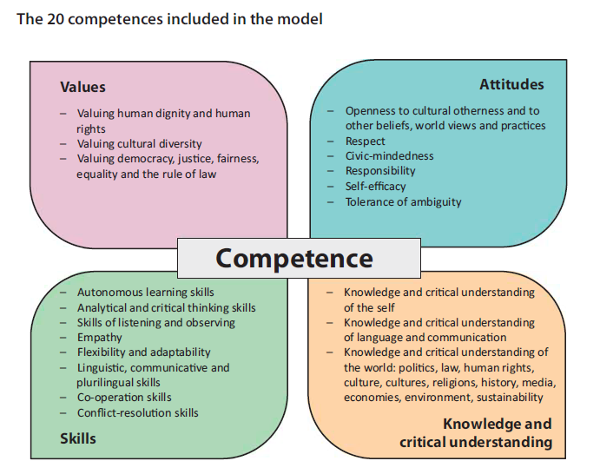

The development of the competences referred to above must also take into account UNESCO’s Target 4.7 of Sustainable Development Goal 4 on Education, which focuses on Global Citizenship Education and Education for Sustainable Development. This can be summarised as follows, “By 2030, ensure that all learners acquire the knowledge and skills needed to promote sustainable development, including, among others, through education for sustainable development and sustainable lifestyles, human rights, gender equality, promotion of a culture of peace and non-violence, global citizenship and appreciation of cultural diversity and of culture’s contribution to sustainable development.”
https://en.unesco.org/themes/gced/sdg47progress

This target is understandably also embedded in the guidelines of the recently elected President of the European Commission (https://ec.europa.eu/commission/sites/beta-political/files/political-guidelines-next-commission en.pdf), which focus on six “headline ambitions” for Europe over the next five years, and beyond:

A European Green Deal
An Economy that works for people
A Europe fit for the digital age
Protecting our European way of life
A stronger Europe in the world
A new push for European democracy

The construction of modern Europe such as we now know it in the European Union has taken a lot of effort, patience and determination in several generations. Over the last period of the history of this undertaking, we have witnessed signs of tiredness, disappointment, scepticism and mistrust. Many voices question the value of the Union and –which is worse- many voices bring back old nightmares of our common history connected to division, exclusion, intolerance, individualism, selfishness and rejection of the different. And for the first time in the history of the Union, one of its member states is leaving. We are faced with an enormous challenge that will test our abilities to get over this situation and make the values of democracy, freedom, tolerance, solidarity, understanding, sustainability, coexistence, peace, acceptance and hospitality prevail.

From this point of view, history teaching in particular has a crucial role to play in the training of responsible and active citizens, and in the developing of respect for all kinds of differences, based on an understanding of national identity and on principles of tolerance. History teaching should also contribute to the elimination of prejudice and stereotypes, through the highlighting, in history syllabuses, of positive mutual influences between different countries, religions and schools of thought over the period of Europe’s historical development. Likewise, through the critical study of misuses of history, whether these stem from denials of historical facts, falsification, omission, ignorance or re-appropriation to ideological ends.

Besides history teaching and the knowledge about the main actors of the construction of the Union and the functioning of its institutions, the European Schools should offer further scope for our students to learn about the challenges, the goals and the ambitions of the European Union in the short, medium and long term, and within a global context.

PROPOSAL: European dimension and civic key competence in the curriculum of the European Schools
From the convictions expressed above, the Spanish presidency puts forward the following proposals:

- Reinforcing the presence of the civic competence, with special reference to European dimension, in the syllabi and the organization of studies of the European schools (making it a compulsory element in the structure of the syllabi; Ref.: 2019-09-D-27-en-2: Structure for all Syllabuses in the system of European Schools).
- Introducing the European dimension and civic competence as a core part of the cross curricular project to be developed by students in the S6-S7 cycle.
- Enhancing the monitoring of the European dimension in the quality control of the European Schools (ES), by means of the whole school inspections (WSI) and audits of the Accredited European Schools (AES).
- Mandating an existing working group to develop these initiatives, in cooperation with the current presidency and future presidency/presidencies.

- Civic competence, with special reference to European dimension, in the syllabi and in the organization of studies of the European schools

The new approach in the teaching and learning processes in the European schools brought by the key competences and the new assessment system should include the presence of the civic competence. Civic competences enable people to act responsibly in society and to interact with other individuals according to values such as transparency, openness, social responsibility and human dignity. They refer to democratic values and develop the individual’s ability to share and to receive, the ability to bond and bridge social groups, and to enforce the respect for human rights.
These competences should appear in the curriculum and the syllabi of all subjects; they should be fostered and developed in the teaching/learning process.

The organization of studies in the ES includes a course, the “European hours”, in the primary cycle, which constitutes an excellent opportunity to underline and value the multicultural and plurinational aspect of our schools. The Spanish presidency believes that the programme of studies for the secondary cycle should also include specific reference to aspects related to the functioning of the European institutions. All aspects related to the construction of the European Union and the values and ideals that sustain the EU, their impact in modern Europe, as well as its present and future challenges, its goals and ambitions in the short, medium and long term should have a place in the curriculum. This could be achieved through a cross-curricular approach or by means of the introduction of a (complementary) course to that effect, with a specific syllabus.
If the proposal is accepted, the document that describes the structure for all syllabuses in the system (2019-09-D-27-en-2: Structure for all Syllabuses in the system of European Schools) should be adapted accordingly in order to make it more explicit that this competence must be clearly expressed in each of them.

- European dimension in a cross curricular project (CCP) - S6/S7 cycle

The introduction of a cross-curricular project in the S6/S7 cycle features prominently among the priorities of the Spanish presidency. The WG “Assessment Secondary” has been developing this project, its features, its syllabus and its impact in the structure of the secondary cycle and in the European Baccalaureate examination. We believe that the cross curricular project offers the students not only a good opportunity to become familiar with research methods but also the scope to liaise different knowledge fields and competences. It could also represent a way of culminating their stay in the system with a “European perspective”: a perspective that would see Europe as a unity, a set of different nations, cultures and histories united by our common values and interests. Our proposal is to make this explicit also in the syllabus of the CCP.

- European dimension in the quality control of the ES by means of the WSI and audits of AES

The general criteria and indicators for WSI (2019-09-D-24) include a section about School Ethos and Climate with a criterion (II.1) related to this sphere: “European Context is established in order to foster mutual understanding and respect for diversity in a multicultural setting”. It contains three indicators:

• The totality of the European dimension is integrated and implemented across the school and in teachers’ planning.
• Teachers plan and work together across language sections.
• Pupils work together across language sections when appropriate.

We propose to change the first bullet point as follows:

- The totality of the European dimension is explicitly integrated in teachers’ planning and is fully implemented across the school.

And also add a new criterion (II.5):
II.5 Civic competence is encouraged and developed through a multidisciplinary/cross-curricular approach.
- Working group (or subgroup) chaired by the current presidency and the future presidency/presidencies
These proposals will be presented to the Joint Board of Inspectors and the Joint Teaching Committee at their respective meetings in _February 2020, as well as to the Budgetary Committee in March 2020, for their opinion. Subject to their favourable opinion, the final draft of this document will be presented to the Board of Governors in April 2020. The Board of Governors will be invited to give a specific mandate to the ‘Pedagogical Reform’ working group and the ‘Task Force’, with the assistance of the ‘Quality Assurance’ working group, to
- develop these proposals, in close cooperation with other relevant working groups;
- analyse, in close cooperation with the Office of the Secretary General and the ‘Roles and Duties of the Inspectors’ working group, the human resources needed to assist the Board of Inspectors in their tasks and responsibilities.

Conclusion
The Spanish presidency wishes to urge the European Schools system to take the necessary steps to reinforce the European dimension in the curriculum and in all aspects of school life in order to endow our learners with the competences and the capacities they need to engage in intercultural dialogue and thus become active participants in democratic processes.

Opinion of the Joint Board of Inspectors and the Joint Teaching Committee
The Joint Board of Inspectors expressed a favourable opinion on the proposal made in the document to strengthen the European dimension in the European School system and European citizenship amongst pupils.
The Spanish Presidency recommended that the future French Presidency should continue with implementation of this proposal and define, in collaboration with the Office of the Secretary-General and the Working Groups concerned, the need for reinforcement in the Pedagogical Development Unit to support the work of Inspectors.
The Joint Teaching Committee expressed a favourable opinion on the Priorities of the Spanish Presidency for the ES 2019/2020 – 2.1. Reform of the European Schools’ Curriculum and their priorities as outlined in the document.

Opinion of the Budgetary Committee
The Budgetary Committee took note of the Spanish Presidency’s priorities.

Proposal
The Joint Board of Inspectors and the Joint Teaching Committee invite the Board of Governors to:

give a specific mandate to the ‘Pedagogical Reform’ working group and the ‘Task Force’, with the assistance of the ‘Quality Assurance’ working group and in cooperation with the Office of the Secretary-General, to
- develop these proposals, in close cooperation with other relevant working groups;
- set up an action plan in light of section “3.2 Tools to handle workload and project management“ of the Final consulting report on human resources allocation and distribution of non-teaching tasks in the European Schools of the IAS, with a view to analysing the additional human resources needed to address the increasing workload of the Pedagogical Unit of the Office of the Secretary General and to assist the Board of Inspectors in their tasks and responsibilities.

Annex I: Implementation and follow up

- The draft document will be forwarded to the following persons for comments and suggestions (9 January 2020):

Secretary General
Deputy Secretary General
Head of the Pedagogical Unit
Head of the Baccalaureate Unit
Members of the Troika of presidencies
Members of the following working groups:
Task Force: Pedagogical Reform
Roles and duties of the Inspectors
Assessment Secondary
Quality Assurance

- The Presidents of the Board of Inspectors (Nursery-Primary and Secondary respectively) will make an oral presentation of the draft document in the forthcoming meetings of the various working groups (13-17 January 2020).

- The revised draft document (also in French and Spanish) will be sent to the members of the Board of Inspectors and the members of the Joint Teaching Committee, and will be discussed at their respective meetings in February 2020.

- The revised draft document will be sent to the members of the Budgetary Committee and will be discussed at its meeting in March 2020.

- Subject to the favourable opinion of the relevant bodies, the final draft of the document will be sent to the members of the Board of Governors and will be discussed at its meeting in Alicante in April 2020.

Madrid, 28 January 2020

