Schola Europaea / Office of the Secretary-General

Pedagogical Development Unit

Ref.: 2019-01-D-28-en-2
Orig.: EN

“Common Framework for Digital Competence” (2018-09-D-32-en-1) – follow-up on Action 1.2
Approved by the Joint Board of Inspectors on the 4 and 6 February 2019 in Brussels
Guidelines for annexes to syllabuses to help implementing digital competence in teaching and learning.

Introduction

The digital competence is one of the eight key competences. It means the confident and critical use of Information and Communication Technologies at work, recreationally and in communication. It must be developed in every learner in the European Schools. To achieve this, coordinated guidance and support are required.

In this perspective, and subject to the amendments proposed during the meeting of 10 October 2018, the Joint Board of Inspectors approved the concept in general of the ‘Common Framework for Digital Competence’ (2018-09-D-32-en-1 - see annex 1) and the immediate entry into force of the proposals for actions set out in points 1.1 and 1.2 of the document in order to start the work as soon as possible.

- Action point 1.1 aims to devise a general digital competence framework for the European Schools, with detailed sub-competences and attainment descriptors adapted to each cycle or year.
- Action point 1.2, in parallel, aims to help teachers fostering digital competence in each subject and cycle or year, by offering them inspiring sets of learning activities examples, that implement certain digital sub-competences. These ideas of learning activities are to be collected and disseminated in annexes to each syllabus. They must be adaptable to the contexts and the needs of teachers and learners.
In this context, digital competence must be developed through learning activities, but not assessed as such. The usual subject-related competences, however, can be evaluated in this way through the digital-mediated activities and their outcomes.

It is hoped that this will be a dynamic process, as learning scenarios and ideas of classroom tasks will have to evolve and develop to better reflect new technologies and the increasing experience and in-depth expertise, of both teachers and learners, in the field of digital learning.
It is hoped that this will contribute to build the European Schools as a learning organisation.

Action 1.2 proposed in the document “Common Framework for Digital Competence” (2018-09-D-32-en-1)

“Action 1.2: In order to meet the 2020 deadline and implementation of the eight key competences, develop simple annexes to each syllabus (no adjustments of the core part of the existing syllabuses) with subject-specific examples of good practices (2-3), in relation to the relevant components of digital competence according to DigComp.
- Examples and a template for activities will be provided by the Pedagogical Development Unit.
- Pedagogical contents produced for the annexes may also be published on the SharePoint ‘Pedagogical material’ (replacement of Learning Gateway, which will become operational in 2019).
Action 1.2 lies in the responsibility of the subject Inspectors.”
[…]
“Actions 1.1 and 1.2 will be conducted in parallel, with a deadline set for the February 2020 pedagogical meetings, with entry into force in September 2020, also in order to comply with the recommendations of the European Council relating to the Key Competences. The Pedagogical Development Unit in cooperation with the Quality Assurance Working Group will produce a specific procedure for the syllabuses in due course.”

To comply with the decision of the JBI, the Pedagogical Development Unit proposes materials to help the Inspectors to develop the annexes. These annexes will contain learning activities with usable and adaptable examples of what teachers can do to implement the digital competences.

This document contains:

- Components of every syllabus' annex
- Components and guidelines of every learning activity
- Specific procedure for the implementation of this document
- DigComp digital sub-competences (annex 1)
- Template (annex 2)
- Examples (annex 3)
- Document 2019-01-D-32 for reminder (annex 4)

What is Digital Competence?
Digital competence means the ability to use digital technology in a confident, critical, creative and secure way. It is defined by the European Digital Competence Framework for Citizens (known as DigComp), which identifies 5 competence areas and 21 sub-competences (see Annex 1).

Each syllabus' annex will use the DigComp sub-competences, as the foreseen “Digital Competence Framework for the European Schools” will be based in particular upon DigComp (although the proficiency levels proposed in DigComp, for example, may be modified in the European Schools Digital Competence Framework).

Will the digital competence be assessed as such?
The subject-related competences will be assessed through the digital-mediated activities and their outcomes. Being a cross-curricular competence, digital competence will be developed through the learning activities, but not assessed as such.

- Components of every syllabus' annex
Each syllabus' annex (for all subjects and all years) will have a harmonised title, include a short introduction and several learning scenarios and classroom activities (a minimum of one detailed scenario and two abridged scenarios).

Title
Learning activities to foster digital competence in [subject].

Introductory text
The digital competence is one of the eight key competences, as stated in the “Framework for the Key Competences for Lifelong Learning in the European Schools” (2018-09-D-67-en), approved by the Joint Teaching Committee in November 2018 (WP: 2018/47) with immediate entry into force. Digital competence means the confident and critical use of Information and Communication Technologies at work, recreationally and in communication. As a cross-curricular competence, it must be developed in every learner in the European Schools.

The following examples of learning activities are meant to facilitate the development of the digital competence for all learners within the area of the subject being studied. They are adaptable to the context and the needs of teachers and learners.

Digital competence will be developed through the learning activities, but not assessed as such. The usual subject-related competences will be assessed through the digital-mediated activities and their outcomes.

- Components of a learning activity
To harmonise each syllabus’ annex and to help the implementation by teachers, each learning activity must include the following components. The subject Inspectors and the teachers participating in the development of the learning scenarios may add any additional content.

  - Types of description of learning activities
A minimum of two types of learning activities has to be proposed: detailed (one activity minimum) and abridged (two activities minimum). This will be mentioned in the title of each learning activity. The learning activities should focus, mainly on the subject related.

- Detailed description of activities are similar to lesson plans. They present a sufficient amount of information to allow teachers and their students to use them quickly.

- Abridged description of activities function as quick sources of inspiration, inviting teachers to develop their creativity. They take a short form and do not go into the details of the pedagogical implementation.

  - Indicators
Each learning activity (detailed and abridged) will be preceded by a set of indicators to allow teachers to quickly understand its characteristics.

Number of sub-competences and depth of coverage
- Each learning activity must cover at least one sub-competence of the digital competence as defined by the European Commission (see Annex 1).
- When a learning activity covers a set of sub-competences, it is asked to specify the intended depth of the coverage: fully covered or partially covered.

N.B.: because DigComp framework has not yet been translated in French and in German (the three vehicular languages), the English original source will be used. When the official Digital Competence Framework for the European Schools has been adopted and translated, all the three vehicular languages can be used.

Digital competence level required
- Each learning activity will specify the level of digital proficiency required by the teacher and by the pupils/students.
- The objective here is not to give a perfectly objective measure, but simply to inform teachers of the likely difficulty of the activity in terms of digital competence.

Teacher’s preparation time
- Each learning activity will specify the expected preparation time for the teacher, prior to the pupils’ and students’ work.
- Here again, the objective is to inform teachers of the likely preparation time required to implement the learning activity.

  - Reference to digital technologies, resources and illustrations

- A diverse and increasingly broad range of digital technologies and resources are available for teaching and learning. In this context, it is recommended that the learning activities refer to technologies and resources commonly available (or easily available) in the European Schools.
- Apart from digital equipment and services deployed in a unified way in the European Schools (like computers room, desktop computers, application suites such as O365, etc.), the pedagogical activities must first refer to generic denominations of digital technologies and services, and may then indicate specific examples of hardware and software/applications (proprietary and open).
- The learning activities can include pictures to document examples of digital technologies and media used and to illustrate learners' work. These pictures will comply with licensing and personal data protection requirements (the pictures shall not allow any identification of individuals).

- Procedure
The Pedagogical Development Unit in cooperation with the Quality Assurance Working Group produced a specific procedure for the annex “Digital competence learning activities” of syllabuses. Once the work is completed, this specific procedure will become obsolete:
- Working group:
In order to find an economical and efficient way of working, the Action 1.2 “development of the annex to the syllabuses” could involve distance meetings or online collaboration (e.g. Teams on O365). If that is not possible, a one-day meeting could be convened and authorised.
To help the subject Inspectors in this respect, the PDU offers to run a preliminary inquiry (via an online form) among the teachers to collect, based on teachers' goodwill, proposals in all subjects and all years. This online form could also ask what digital sub-competences are covered by each proposal. The PDU will then share with subject Inspectors the results, to help them identify and choose valuable proposals.
- Time schedule:
Action 1.2 will be conducted with a deadline set for the February 2020 pedagogical meetings, with entry into force in September 2020. This is in order to comply with the recommendations of the European Council relating to the Key Competences.
- Approval:
As it is an annex to the syllabus, a formal approval by the JTC is not necessary. According to the rules, the annex will not necessarily be translated. When the annex is ready, the subject Inspector will send it to the QA Working group for verification, according to the deadlines. Once finalized, the annex will be added to the syllabus.
The syllabus will be forwarded as “Written communication” to the JTC for their information, and published on the ES Website: www.eursc.eu, with entry into force in September 2020 at the latest.

- Decision
The JBI approved, with immediate entry into force, document 2019-01-D-28 as a whole and particularly its follow-up actions, which related to action 1.2 (of document 2018-09-D-32). That action point sought to help teachers to promote digital competence in each subject and within each cycle or year, by giving them examples of learning activities on which they could draw. Those ideas for learning activities would be gathered together and circulated in an annex to each syllabus. It pointed out that such annexes would be useful for the transition phase involved in final approval of the ‘Common Framework for Digital Competence’.
The JBI also approved the specific procedure for preparing the annex ‘Learning activities to foster Digital Competence’ to the syllabuses. Once the work had been completed, that specific procedure would become obsolete.
In order to be efficient in cost and time terms, the JBI proposed firstly, the development of a common annex by type of language subject (e.g. an annex for all L1s, another for all L2s, etc.) and secondly, for the new syllabuses, allowing the Inspector responsible for the subject to be the sole judge of whether or not an annex should be produced, according to the degree of implementation of digital competence in the current syllabus.
The document “Procedure for the production, management and publication of the syllabuses of the European Schools” (2014-01-D-41) will be adapted.

Annex 1. DigComp digital sub-competences.

area | sub-competence | description
1. Information and data literacy | 1.1 Browsing, searching and filtering data, information and digital content | To articulate information needs, to search for data, information and content in digital environments, to access them and to navigate between them. To create and update personal search strategies.
 | 1.2 Evaluating data, information and digital content | To analyse, compare and critically evaluate the credibility and reliability of sources of data, information and digital content. To analyse, interpret and critically evaluate the data, information and digital content.
 | 1.3 Managing data, information and digital content | To organise, store and retrieve data, information and content in digital environments. To organise and process them in a structured environment.
2. Communication and collaboration | 2.1 Interacting through digital technologies | To interact through a variety of digital technologies and to understand appropriate digital communication means for a given context.
 | 2.2 Sharing through digital technologies | To share data, information and digital content with others through appropriate digital technologies. To act as an intermediary, to know about referencing and attribution practices.
 | 2.3 Engaging in citizenship through digital technologies | To participate in society through the use of public and private digital services. To seek opportunities for self-empowerment and for participatory citizenship through appropriate digital technologies.
 | 2.4 Collaborating through digital technologies | To use digital tools and technologies for collaborative processes, and for co-construction and co-creation of resources and knowledge
 | 2.5 Netiquette | To be aware of behavioural norms and knowhow while using digital technologies and interacting in digital environments. To adapt communication strategies to the specific audience and to be aware of cultural and generational diversity in digital environments.
 | 2.6 Managing digital identity | To create and manage one or multiple digital identities, to be able to protect one’s reputation, to deal with the data that one produces through several digital tools, environments and services.
3. Digital content creation | 3.1 Developing digital content | To create content in different formats (e.g. data, text, multimedia), to edit and improve existing content, to express oneself through digital means.
 | 3.2 Integrating and re-elaborating digital content | To modify, refine and integrate new information and content into an existing body of knowledge and resources to create new, original and relevant content and knowledge.
 | 3.3 Copyright and licences | To understand how copyright and licences apply to digital information and content.
 | 3.4 Programming | To plan and develop a sequence of understandable instructions for a computing system to solve a given problem or to perform a specific task.

4. Safety | 4.1 Protecting devices | To protect devices and data, to understand risks and threats in digital environments, to know about safety and security measures and to have due regard to reliability and privacy.
 | 4.2 Protecting personal data and privacy | To protect personal data and privacy in digital environments. To understand how to share personally identifiable information while protecting self and others from dangers (e.g. fraud). To understand that digital services use a “Privacy policy” to declare how personal data is used.
 | 4.3 Protecting health and well-being | To avoid health-risks related with the use of digital technologies in terms of threats to physical and psychological well-being. To be able to protect self and others from possible dangers in digital environments (e.g. cyber bullying). To be aware of digital technologies for social well-being and inclusion.
 | 4.4 Protecting the environment | To be aware of the environmental impact of digital technologies and their use.
5. Problem solving | 5.1 Solving technical problems | To identify technical problems when operating devices and using digital environments, and to solve them (from trouble-shooting to solving more complex problems).
 | 5.2 Identifying needs and technological responses | To assess needs and to identify, evaluate, select and use digital tools and possible technological responses to solve them. To adjust and customise digital environments to personal needs (e.g. accessibility).
 | 5.3 Creatively using digital technologies | To use digital tools and technologies to create knowledge and to innovate processes and products. To engage individually and collectively in cognitive processing to understand and resolve conceptual problems and problem situations in digital environments.
 | 5.4 Identifying digital competence gaps | To understand where one’s own digital competence needs to be improved or updated. To be able to support others with their digital competence development. To seek opportunities for self-development and to keep upto-date with the digital evolution.

Annex 2. Templates

- Learning Activity Template for Primary and Secondary

Learning activity n° […] – Detailed/Abridged description

Digital competence level required
 | Teacher | Learners
basic
independent
proficient
Teacher’s preparation time
short | <1 period
medium | 1-2 periods
long | >2 periods

Digital competence coverage (DigComp Framework)
Area | Sub-competence | Description | Competence coverage
 |  |  | fully | partially

Title

Brief description

N.B.: Abridged descriptions may skip the following items, as they will have been covered under the previous title “Brief description”

Topic(s)/link(s) with the syllabus

Learning objective(s)

Duration

Materials/equipment

Steps and tasks

Assessment

- Learning Activity Template for Nursery

Learning activity n° […] – Detailed/Abridged description

Digital competence level required
 | Teacher | Learners
basic
independent
proficient
Teacher’s preparation time
short | <1 period
medium | 1-2 periods
long | >2 periods

Digital competence coverage (DigComp Framework)
Area | Sub-competence | Description | Competence coverage
 |  |  | fully | partially

Title

Brief description

Links to Early Education curriculum
 | coverage
 | fully | partially
Me and my body
Me as a person
Me and the others
Me and the world

N.B.: Abridged descriptions may skip the following items, as they will have been covered under the previous title “Brief description”

Learning objective(s)

Duration

Materials/equipment

Steps and tasks

Assessment

Annex 3. Learning Activities Examples

The following examples are related to Philosophy 2 and 4 (S6 and S7).

Learning activity n°1 – Abridged description

Digital competence level required
 | Teacher | Learners
basic | X | X
independent
proficient
Teacher’s preparation time
short | <1 period | X
medium | 1-2 periods
long | >2 periods

Digital competence coverage (DigComp Framework)
Area | Competence | Description | Competence coverage
 |  |  | fully | partially
2. Communication and collaboration | 2.1 Interacting through digital technologies | To interact through a variety of digital technologies and to understand appropriate digital communication means for a given context. |  | X
2. Communication and collaboration | 2.4 Collaborating through digital technologies | To use digital tools and technologies for collaborative processes, and for co-construction and co-creation of resources and knowledge | X | X
3. Digital content creation | 3.2 Integrating and re-elaborating digital content | To modify, refine and integrate new information and content into an existing body of knowledge and resources to create new, original and relevant content and knowledge. |  | X

Title
Reading, understanding and questioning a text with color coding annotations.

Brief description
To develop their ability to read, understand and question a text, students are asked to use a word processor to highlight an annotate a short philosophical text. They can also use comments function, to add written information on the text and to ask questions. By sharing their documents with each other’s, students can then better understand and discuss the text.
The teacher will distribute the original philosophical extract on a word processor document, by e-mail or by posting it on an online space (like Microsoft TEAMS). The students, individually or in group, will:
- Read the text and highlight it in different colors, using a common color code (blue = contentions and statements, green = reasons, red = objections, yellow = examples, etc.).
- Insert comments on sections of the text to specify their specific function (introduction, concession or counter-argument, conclusion, etc.).
- Insert comments on a specific element to questions the text and challenge its assumptions.
The students could finally share their documents (ideally on a collaborative tool, like Microsoft Word Online), and run a peer evaluation, using the comments to develop the discussion.

Learning activity n°2 – Abridged description

Digital competence level required
 | Teacher | Learners
basic
independent | X | X
proficient
Teacher’s preparation time
short | <1 period
medium | 1-2 periods | X
long | >2 periods

Digital competence coverage (DigComp Framework)
Area | Competence | Description | Competence coverage
 |  |  | fully | partially
2. Communication and collaboration | 2.2 Sharing through digital technologies | To share data, information and digital content with others through appropriate digital technologies. To act as an intermediary, to know about referencing and attribution practices. |  | X
3. Digital content creation | 3.1 Developing digital content | To create content in different formats (e.g. data, text, multimedia), to edit and improve existing content, to express oneself through digital means. |  | X
3. Digital content creation | 3.2 Integrating and re-elaborating digital content | To modify, refine and integrate new information and content into an existing body of knowledge and resources to create new, original and relevant content and knowledge. | X
5. Problem solving | 5.4 Identifying digital competence gaps | To understand where one’s own digital competence needs to be improved or updated. To be able to support others with their digital competence development. To seek opportunities for self-development and to keep upto-date with the digital evolution. |  | X

Title
Question places with philosophical quotations.

Brief description
To develop the students' culture, but also their reflection and questioning, suggest that they associate philosophical quotations with places on a Geographic Information System (like OpenStreetMap, Google My Maps…). Students place markers at the chosen locations on the map and they will add quotation.

The markers placed on the map can vary graphically (colors, symbols, pictograms...) depending on whether the place illustrates an idea contained in the quotation (e. g. a marker placed at UN Headquarters in New York with Aristotle's quotation "Man is by nature a political animal"), or whether the place is challenged by the quotation (e.g. a marker placed at the Wolfsburg Volkswagen factory in Germany with the quotation by Karl Marx: "The reign of freedom begins only from the moment when the work dictated by necessity stops").
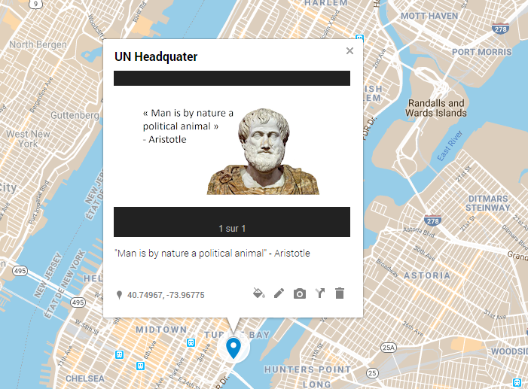
The teacher can propose a limited set of quotes and students will compare and discuss how they have been associated with different geographical locations (chosen by students individually or in groups).

Learning activity n°3 – Abridged description

Digital competence level required
 | Teacher | Learners
basic
independent | X
proficient |  | X
Teacher’s preparation time
short | <1 period
medium | 1-2 periods
long | >2 periods | X

Digital competence coverage (DigComp Framework)
Area | Competence | Description | Competence coverage
 |  |  | fully | partially
1. Information and data litteracy | 1.1 Browsing, searching and filtering data, information and digital content | To articulate information needs, to search for data, information and content in digital environments, to access them and to navigate between them. To create and update personal search strategies. |  | X
2. Communication and collaboration | 2.1 Interacting through digital technologies | To interact through a variety of digital technologies and to understand appropriate digital communication means for a given context. |  | X
2. Communication and collaboration | 2.2 Sharing through digital technologies | To share data, information and digital content with others through appropriate digital technologies. To act as an intermediary, to know about referencing and attribution practices. | X
3. Digital content creation | 3.1 Developing digital content | To create content in different formats (e.g. data, text, multimedia), to edit and improve existing content, to express oneself through digital means. | X
3. Digital content creation | 3.2 Integrating and re-elaborating digital content | To modify, refine and integrate new information and content into an existing body of knowledge and resources to create new, original and relevant content and knowledge. |  | X

Title
“Booktrailers" to make students eager to read philosophy books!

Brief description
The teacher assigns students (individually or in groups) pages or chapters selected from philosophy books in the school library. Each student/group must create a short video (about 30 seconds) to make their peers eager to read the book based on the assigned excerpt. It is about creating a kind of "booktrailer".
- The students first proceed with an analytical reading of the text. They identify the essential information on the philosopher, the nature of the work, the philosophical problem addressed, the thesis defended, possibly also on the importance and influence of the text...
- The students then write the script (sequence and content) of the video, using a collaborative word processor (e. g. Word Online...).
- With the teacher's agreement (who checks the relevance of the script content), the video is finally made on an application allowing an export to video format (for example PowerPoint by exporting the slide show to video format, Adobe Spark or a mobile application...). The video is sounded by a royalty-free soundtrack (dully credited), or by a narrative recorded by the students. Illustration images will be free of copyright (dully credited). Subject to adequate parental permission, students may also film themselves.
The video can be shared with the class (e. g. in Microsoft Teams) or on the school's internal video network (e. g. Microsoft Stream). It may even be directly available from library books, through QR codes on their covers containing links to the videos.

Learning activity n°4 – Abridged description

Digital competence level required
 | Teacher | Learners
basic |  | X
independent | X
proficient
Teacher’s preparation time
short | <1 period
medium | 1-2 periods | X
long | >2 periods

Digital competence coverage (DigComp Framework)
Area | Competence | Description | Competence coverage
 |  |  | fully | partially
2. Communication and collaboration | 2.4 Collaborating through digital technologies | To use digital tools and technologies for collaborative processes, and for co-construction and co-creation of resources and knowledge. |  | X
3. Digital content creation | 3.2 Integrating and re-elaborating digital content | To modify, refine and integrate new information and content into an existing body of knowledge and resources to create new, original and relevant content and knowledge. | X

Title
Improving analytical reasoning and argumentative competence.

Brief description
Argument mapping or argument visualization can foster students’ analytical and reasoning skills. To do so, students can use digital dedicated tools, like www.argument.mindmup.com, an easy, free and open platform for collaborative argument mapping.
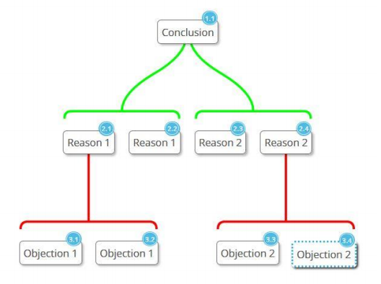
Students can work in groups to create visualizations of arguments excerpted from appropriated philosophical texts. They can receive ongoing feedback on their work-in-progress, and revise their work accordingly.
Opposite is an example of a simple argument visualization (reasons are in green and objections in red).

Learning activity n° 5 – Detailed description

Digital competence level required
 | Teacher | Learners
basic
independent | X | X
proficient
Teacher’s preparation time
short | <1 period
medium | 1-2 periods | X
long | >2 periods

Digital competence coverage (DigComp Framework)
Area | Competence | Description | Competence coverage
 |  |  | fully | partially
1. Information and data literacy | 1.1 Browsing, searching and filtering data, information and digital content | To articulate information needs, to search for data, information and content in digital environments, to access them and to navigate between them. To create and update personal search strategies. | X
1. Information and data literacy | 1.3 Managing data, information and digital content | To organise, store and retrieve data, information and content in digital environments. To organise and process them in a structured environment. |  | X
2. Communication and collaboration | 2.2 Sharing through digital technologies | To share data, information and digital content with others through appropriate digital technologies. To act as an intermediary, to know about referencing and attribution practices. | X
3. Digital content creation | 3.3 Copyright and licences | To understand how copyright and licences apply to digital information and content. |  | X

Title
Exploration of philosophical ideas through online image research and interpretation.

Brief description
Students (alone or in groups) will explore different meanings of a philosophical notion, in conjunction with visual content. They will search online for visual illustrations that are consistent with the examined notion. They will write, present and defend an interpretation of the relation between the image(s) and the notion. They will use this work to produce a definition of the examined notion.

Topic(s)/link(s) with the syllabus
Any philosophical idea, notion or concept in the syllabus.

Learning objective(s)
- Students will be able to develop philosophical thinking (understanding the polysemy of the philosophical terms, being able to circulate from the concrete to the abstract, being able to produce definitions) in conjunction with visual literacy.
- Students will be able to understand that images not only refer to realities (denotation: what is observed?), but also to implicit significations (connotation: what does it mean?), especially when images are ambiguous, symbolic, involving emotion and imagination.
- Students will be able to develop their knowledge of the European heritage.
- Students will be able to develop information literacy (content search using an online platform).

Duration: 2 periods (adjustable to the context and the group dynamics).
Materials/equipment
- computers or mobile devices,
- access to an online library, e.g. www.europeana.eu (the EU digital platform for cultural heritage),
- web applications: online web canvas/boards (OneNote or similar), presentation tools (PowerPoint or similar), document editors (Word or similar).
N.B.: printer, paper and glue can be used for a “low tech” variation of this activity.

Steps and tasks
To explore the different meanings of a philosophical notion, students are invited to search online for and select visual illustrations of this notion, and then to justify the link they conceive between the image(s) and the notion Students can work in groups. Each group will:
- search online and select two images,
- write on word processor an interpretation for each image,
- present their findings and interpretations to the class. The class will challenge the relevance of the proposals.
To close the activity, the teacher can propose a synthesis of the main meanings of the examined term or ask the students to do this individually (in class or as a take home task).

Assessment:
The skills usually assessed in the subject (see subject syllabus) will be examined through the work carried out during the different phases of this activity, as well as through its results.
Digital competence will not be assessed as such.

Activité d’apprentissage n° 6 – Description détaillée

Niveau de compétence digitale requis
 | Teacher | Learners
basic
independent | X | X
proficient
Temps de préparation pour l’enseignant
court | <1 période
moyen | 1-2 périodes
long | >2 périodes | X

Couverture de la compétence numérique (cadre de référence DigComp)
Aire | Compétence | Description | Couverture de la compétence
 |  |  | pleine | partielle
1. Information and data literacy | 1.3 Managing data, information and digital content | To organise, store and retrieve data, information and content in digital environments. To organise and process them in a structured environment. |  | X
2. Communication and collaboration | 2.4 Collaborating through digital technologies | To use digital tools and technologies for collaborative processes, and for co-construction and co-creation of resources and knowledge. | X
3. Digital content creation | 3.1 Developing digital content | To create content in different formats (e.g. data, text, multimedia), to edit and improve existing content, to express oneself through digital means. | X

Titre
L’organigramme d’idées comme support pour l’analyse d’un texte

Brève description
L’activité vise la présentation d’un texte par le biais de la réalisation d’un organigramme d’idées.
L'organigramme d'idées est un outil qui permet de visualiser et d'organiser les concepts/idées/arguments en se servant de formes disponibles via une application mise en page ou de traitement de texte avancée, une application de dessin ou de conception de diaporama.
L’organigramme doit traduire clairement la hiérarchie des idées. Sous forme de poster, il doit servir de support de communication visuelle pour donner envie au lecteur d’approfondir le sujet.
L’organigramme peut être accompagné d’un texte bref, permettant au lecteur de le rendre compréhensible, même sans explication orale.

Sujet(s)/lien(s) avec le syllabus
Toute idée, notion ou concept philosophique du syllabus.

Objectif(s) d'apprentissage
- Identifier et comprendre l’argumentation d’un texte.
- Communiquer une argumentation.

Durée
On peut organiser le travail sur deux périodes.

Matériel/équipement /
Pour cette activité, on choisira une application disposant des fonctions graphiques nécessaires : éditeur de texte avancé (OpenOffice Writer, Microsoft Word…), application de présentation ou de diaporama, application de dessin…

Étapes et tâches
- Présenter l’activité.
- Présenter les fonctions de base de l’application utilisée. A ce stade et durant l’activité, ne pas hésiter à identifier des élèves ‘‘experts“ pouvant guider leurs pairs.
- Attribuer les textes aux élèves.
- Organiser le travail de manière itérative et collaborative, en demandant aux élèves de présenter les étapes de leur travail à leurs pairs, afin de receuillir des idées d’amélioration.

Voici deux exemples d’organigrammes réalisés à partir de textes philosophiques.

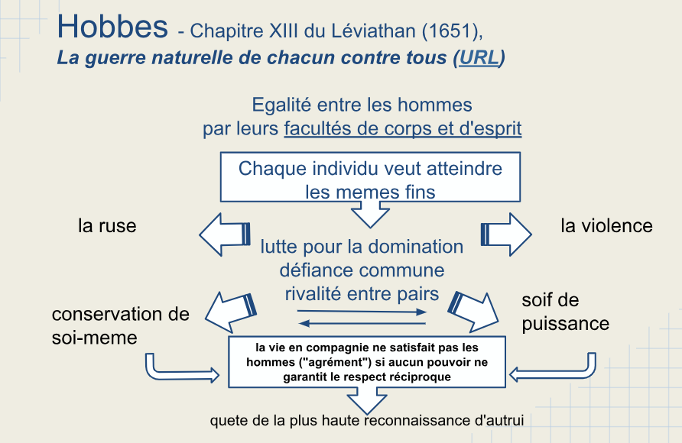

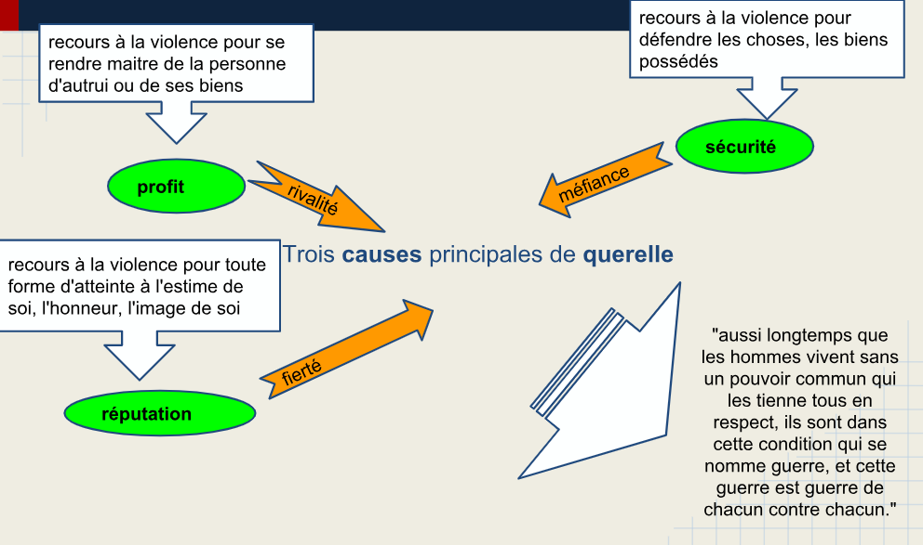

Évaluation
Les compétences habituellement évaluées dans la matière (voir le syllabus de la matière) seront examinées à travers les travaux réalisés au cours des différentes phases de l’activité, ainsi qu'à travers ses résultats.
La compétence numérique ne sera pas évaluée en tant que telle.

Activité d’apprentissage n° 7 – Description détaillée

Niveau de compétence digitale requis
 | Teacher | Learners
basic
independent | X | X
proficient
Temps de préparation pour l’enseignant
court | <1 période
moyen | 1-2 périodes
long | >2 périodes | X

Couverture de la compétence numérique (cadre de référence DigComp)
Aire | Compétence | Description | Couverture de la compétence
 |  |  | pleine | partielle
1. Information and data literacy | 1.3 Managing data, information and digital content | To organise, store and retrieve data, information and content in digital environments. To organise and process them in a structured environment. |  | X
2. Communication and collaboration | 2.4 Collaborating through digital technologies | To use digital tools and technologies for collaborative processes, and for co-construction and co-creation of resources and knowledge. | X
3. Digital content creation | 3.1 Developing digital content | To create content in different formats (e.g. data, text, multimedia), to edit and improve existing content, to express oneself through digital means. | X

Titre
Le poster conceptuel comme outil pour exposer un concept ou une thèse philosophique.

Brève description
L’activité vise la présentation d’un concept philosophique par le biais de la réalisation d’un poster conceptuel. Le but du poster est de présenter un concept philosophique, une théorie ou une doctrine à un public de non-initiés. Cela oblige à prendre le point de vue d’un destinataire débutant, et pour cela il faut viser la plus grande clarté dans la présentation de la problématique et dans le vocabulaire utilisé.
- Le poster doit être fidèle à son objet (cohérent et suffisamment complet).
- Le poster doit retenir l'attention : c'est un support de communication visuelle.
- Le poster doit donner envie d’approfondir le sujet.
Le poster doit donc être pédagogique, présenter un enchaînement logique et ne pas être trop dense. Il doit se suffire à lui-même, être compréhensible même sans explications complémentaires.

Sujet(s)/lien(s) avec le syllabus
Toute élément (idée, notion, concept, théorie ou doctrine) philosophique du syllabus.

Objectif(s) d'apprentissage
- Identifier et comprendre les articulations entre les éléments d’une conception philosophique.
- Transcrire et communiquer visuellement un contenu abstrait.

Durée
On peut organiser le travail sur deux périodes.

Matériel/équipement /
Pour cette activité, on choisira une application ayant disposant des fonctions graphiques nécessaires : éditeur de texte avancé (OpenOffice Writer, Microsoft Word…), application de présentation ou de diaporama, application de dessin…

Étapes et tâches
- Présenter l’activité et les fonctions de base de l’application utilisée. A ce stade et durant l’activité, ne pas hésiter à identifier des élèves ‘‘experts“ pour guider les autres.
- Pour réaliser le poster :
- Scénario : définir : le contenu, la problématique, les grandes parties de l’argumentation
- Story-board : définir les pavés de textes, les documents graphiques, la trame graphique c.à.d. la mise en page du poster.
- Réalisation : via l’application choisie.
- Communication : envoi des images à l’enseignant (par courriel ou en les téleversant dans une bibliothèque en ligne partagée).
- Organiser le travail de manière itérative et collaborative, en demandant aux élèves de présenter les étapes de leur travail à leurs pairs, afin de receuillir des idées d’amélioration.

Exemple de poster :

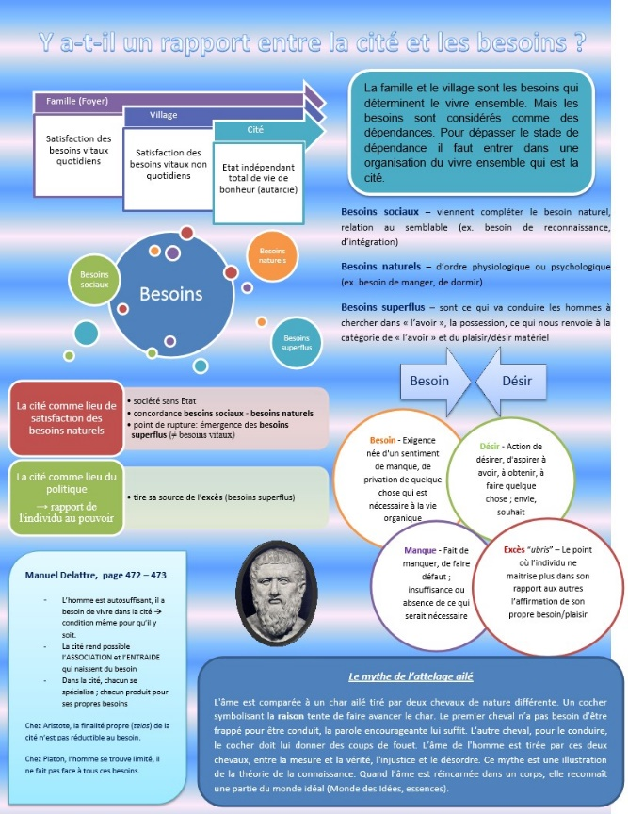

Évaluation
Le poster conceptuel est évalué sur base des critères repris sur une fiche préalablement communiquée à l’élève :

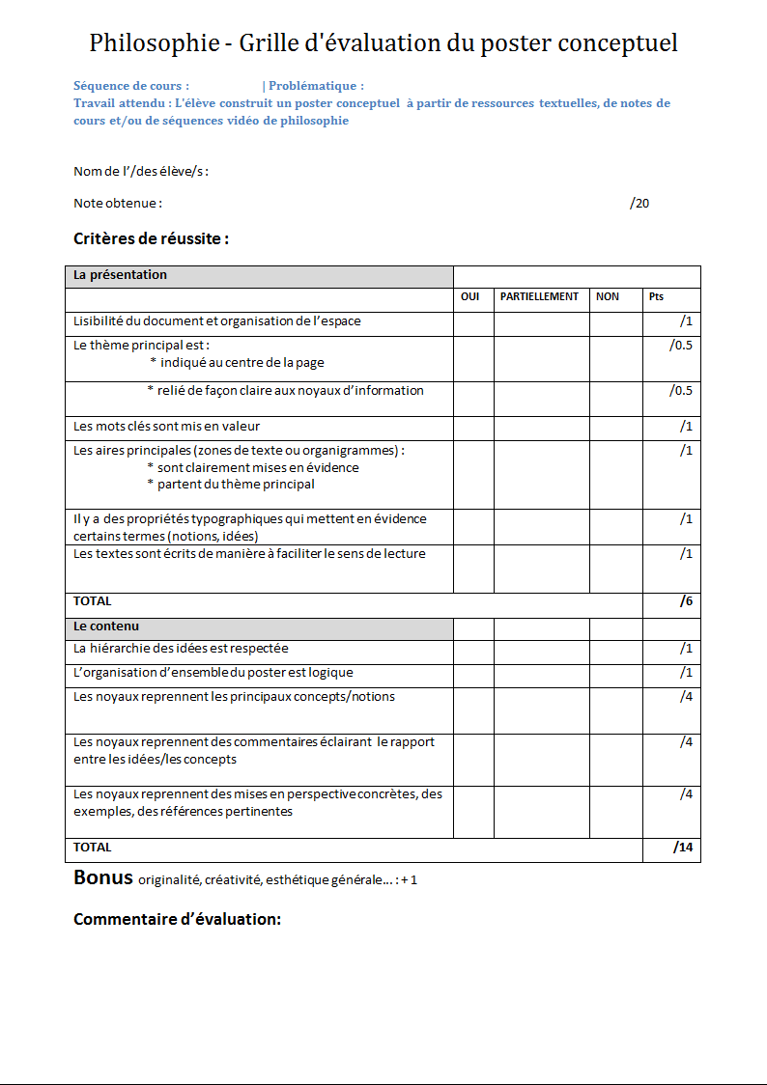

Annex 4. Document 2018-09-D-32

Schola Europaea / Office of the Secretary-General
Pedagogical Development Unit

Ref.: 2018-09-D-32-en-2
Orig.: EN

Common Framework for ‘Digital Competence’
Approved by the Joint Board of Inspectors on 10 October 2018 – Brussels

Immediate entry into force

Introduction

In order to:
- comply with the mandate of the IT-PEDA Strategy Working Group, which, amongst other things, requires the following to be done:
  - to suggest actions required to ensure that students’ digital competence is properly enhanced at all stages of their education,
  - to propose models for ICT use for pedagogical purposes, including for children with special educational needs,
  - to review the role of digital competence (referred as DC) in the organisation of studies and in syllabuses;
- respond to the report of the online IT-PEDA survey (2018-01-D-22) presented at the JTC meeting in February 2018;
- comply with the priorities and the following operational targets of the ‘IT Multi-Annual Plan’ (approved by the Board of Governors at its April 2018 meeting (2018-01-D-79)) (see Annex 1 to this document):
  - 5.3. ‘Definition of the quality criteria for digital competence syllabuses’,
  - 5.4. ‘Review of syllabuses and modifications if required’;

under request by the IT-PEDA Strategy Working Group, the Pedagogical Development Unit, assessed all the current syllabuses to determine:
- the compliance of pre-2012 syllabuses (before the Quality Assurance working group) with the document ‘Structure of all syllabuses in the system of the European Schools’ 2011-09-D-47,
- and the general implementation level of digital competence within syllabuses.

During its meetings, the IT-PEDA Strategy Working Group engaged in a great deal of discussion on this subject and in reflection as to how to design and set up the best Digital Competence Framework for European Schools students. In this context, the Working Group had conducted research on existing digital competence frameworks used by major educational systems, with constant emphasis on being in line with the DigComp (European Digital Competence Framework) and with the European Schools’ specificities.

Following these analyses, the IT-PEDA Strategy Working Group recommends developing and implementing a Cross-Curricular Digital Competence Framework for the European Schools to develop the digital competence of pupils/students and support the teachers in fulfilling this aim.
The deadline should be the year 2020, in order to respect the Council recommendation.
This recommendation and the concept were presented to the Quality Assurance Working Group (12.09.2018), which supports the complete project and the actions proposed below.

Proposal for actions

Under the responsibility of both ICT Inspectors (members of the IT-PEDA WG), two actions are proposed in parallel, to help Inspectors and teachers to promote the use of new technologies and media in teaching and learning, and to meet the digital competence objective as one of the eight key competences required by the European Directives on the subject:

Action 1.1: Devise a common Digital Competence Framework (DCF) tailored to the specific needs and IT vision of the European Schools, based on the DigComp framework and other high-quality frameworks (e.g. Wales Government Digital Competence Framework). This framework will be cross-curricular.
Depending on their nature, the elements of digital competence will be allocated to the different subjects and divided out according to the cycles in the curriculum.
This Common Digital Competence Framework will have to be approved by the JTC (probably not before October 2019).
Action 1.1 lies in the responsibility of both ICT Inspectors involved in the IT-PEDA WG.

Action 1.2: In order to meet the 2020 deadline and implementation of the eight key competences, develop simple annexes to each syllabus (no adjustments of the core part of the existing syllabuses) with subject-specific examples of good practices (2-3), in relation to the relevant components of digital competence according to DigComp.
- Examples and a template for activities will be provided by the Pedagogical Development Unit.
- Pedagogical contents produced for the annexes may also be published on the SharePoint ‘Pedagogical material’ (replacement of Learning Gateway, which will become operational in 2019).
Action 1.2 lies in the responsibility of the subject Inspectors.
Action 2: When the Digital Competence Framework is approved, each subject Inspector (with his/her working group) will be requested to identify which dimensions of digital competence are covered by the syllabus for each cycle. The aim is:
- to ensure that digital competence is fully implemented and taught in every cycle (N.B. not all dimensions of DC have to be addressed in every subject).
- to provide, whenever possible, short examples of how DC can be implemented, in order to help teachers in designing their lessons.
As regards this latter action, more practical information will be provided by the IT-PEDA sub-group in due course.
Action 2 lies in the responsibility of the subject Inspectors.
All these materials developed by Inspectors/working groups will offer a good basis for the local and centralised training courses that have to be foreseen for implementation of the Digital Competence Framework – see document 2018-09-D-37 (Encourage exchange and sharing of good practices of digital competence in teaching and learning, by offering specific training courses).
The final timeline for the complete deployment of the Common Digital Competence Framework still has to be discussed by the IT-PEDA and IT-ADM Working Groups.

Financial impact
As these actions are directly related to a decision of the Board of Governors (mandate of the IT Strategy Groups and IT Multi-Annual Plan) and the EU recommendations and as the ‘2020’ deadline has to be met, they should be regarded as priorities. In this context, the actions must be carried out as far as possible, within the limits set by the budget.
Action 1: As it is under the mandate of the IT-PEDA Working Group, it is already a priority and must be included in the budget.
Action 1.2: In order to find an economical and efficient way of working, development of the annex to the syllabuses could involve distance meetings or online collaboration (e.g. Teams on O365). If that is not possible, a one-day meeting could be allocated.
Action 2: As this action can benefit from the work done under Action 1.2. and as it does not involve much development work, a two-day meeting could be allocated.

Decision
The IT-PEDA Working Group has invited the JBI to approve the concept in general and the proposal actions set out in points 1.1, 1.2 in particular, with immediate entry into force, in order to start the work as soon as possible.
Actions 1.1 and 1.2 will be conducted in parallel, with a deadline set for the February 2020 pedagogical meetings, with entry into force in September 2020, also in order to comply with the recommendations of the European Council relating to the Key Competences. The Pedagogical Development Unit in cooperation with the Quality Assurance Working Group will produce a specific procedure for the syllabuses in due course.
Once the Common Digital Competence Framework is approved, Action 2 could start. The documents ‘Structure for all syllabuses in the system of the European schools’ 2011-09-D-47 and ‘Procedure for the production, management and publication of the syllabuses of the European Schools’ 2014-01-D-41 will be adapted accordingly.
Subject to the amendments proposed during the meeting, the JBI approved the general concept of the "Common Framework for Digital Competence" as proposed here above with immediate entry into force.
These amendments concern:
- The addition of guidelines for technical and digital competence as is already the case for the primary cycle
- Estimating human and financial resources to carry out projects
- Estimating the technical availability in schools as to the feasibility of certain projects
It is also proposed that these guidelines, once finalised, be incorporated into the document "Structure for all syllabuses in the system of the European schools" (2011-09-D-47)
The JBI requests the IT-PEDA WG to follow up the project for the next pedagogical meetings.

Annex 1 Extract of the IT-Multi-Annual Plan
Operational target  5.3. | Definition of the quality criteria for digital competence syllabuses
Main phases | - The IT-PED Working Group will examine the syllabuses and decide on points of intervention (improvement) on site during the Working Group meeting.  - The IT-PED Working Group will draw up a document containing guidelines for the inspectors’ committee. Creating recommendations to improve the online syllabuses with key skills.  Possible remarks and elements:  - Checking of syllabuses (Are ICT sufficiently represented?)  - Focus on annexes  - Ask pedagogical committees for their opinion and mandate.
Expected result(s) | Better quality of the syllabuses. A global approach to curriculum development and teaching in the classroom.
Indicators of security | Guidelines for ICT as key skills in syllabuses.
Completion date | December 2018
Needs/resources | Framework for developing digital resources with the EU.
Responsibility | IT-PEDA Strategy Group, Inspectors

Operational target  5.4. | Review of syllabuses and modifications if required
Main phases | - Review of each syllabus (they will be modified by the inspectors).  - Checking the quality of the syllabuses.  - Research and publication of documentation to help teachers to implement basic education on ICT (e.g. multilingual software already on the market, or internal innovations).
Expected result(s) | The annexes will include orientation on basic teaching about ICT. A curriculum based on skills / teaching.
Security indicators | - Updating of courses.  - A database with digital complementary teaching tools on a common platform.
Completion date | 2020
Needs/resources | Updating the framework for syllabuses (document entitled ‘Structure of syllabuses’…)  Common platform
Responsibility | Pedagogical Development Unit, Inspectors

https://ec.europa.eu/jrc/en/digcomp.
For example, in a writing activity one will first refer to word processors, and then mention particular applications.
Source : « DigComp into Action: Get inspired, make it happen. A user guide to the European Digital Competence Framework” (Joint Research Center, may 2018), https://ec.europa.eu/jrc/en/publication/eur-scientific-and-technical-research-reports/digcomp-action-get-inspired-make-it-happen-user-guide-european-digital-competence-framework
“Argument visualizations are tree diagrams that illustrate logical relations in text by employing a combination of color and grouping cues to guide visual attention to salient elements and to bind elements that share a common function. Their hierarchical layout is intended to reflect the hierarchical structure of real arguments. These features make them helpful for both organizing and navigating complex argumentative texts and for communicating arguments transparently” (Cullen, Simon, et al. “Improving Analytical Reasoning and Argument Understanding: a Quasi-Experimental Field Study of Argument Visualization.” Npj Science of Learning, vol. 3, no. 1, 2018, doi:10.1038/s41539-018-0038-5; https://www.nature.com/articles/s41539-018-0038-5). For a presentation of the argument visualization methodology, visit https://maps.simoncullen.org.
In order to comply with European Commission and the 8 Key competences terminology from now on, and when necessary, the term ‘Digital competence’ (DC) will gradually replace ‘ICT’ and ‘IT’.
The external expert - member of the Reform pedagogical/Task force Working Group - has also done this kind of analysis, see document “Proposal of a Framework for the Key Competences for Lifelong Learning in the European Schools” ref: 2018-09-D-67.
https://ec.europa.eu/jrc/en/digcomp.
In line with the results of the online survey and with the recommendations made by the IT-PEDA Strategy Group resulting from its various types of work on the subject, digital competence ought to be regarded as a cross-curricular competence at all teaching levels in the schools and in all the subjects taught.
e.g. Latest Council recommendation of 22 May 2018 on Key Competences for Lifelong Learning, 2018/0008 (NLE). The Reference Framework sets out eight key competences, including digital competence. Relevant extracts: - “2.4. increasing and improving the level of digital competences at all stages of education and training, across all segments of the population” - “3.1. promoting a variety of learning approaches and environments, including the adequate use of digital technologies, in education, training and learning settings” - “Learners, educational staff and learning providers could be encouraged to use digital technologies to improve learning and to support the development of digital competences”
The IT Vision is currently under development by the IT-PEDA WG. The aim of this vision is to define the main goals of the European Schools in the context of the development of the digital competences, so as to provide a mission statement that would be relevant to the future pedagogical development of the system as a whole.
http://learning.gov.wales/resources/browse-all/digital-competence-framework/?skip=1&lang=en.
e.g. social elements of digital competence such as “Netiquette” or “Engaging in citizenship through digital technologies” can be addressed in subjects like Discovery of the World/Human Sciences, European Hours/Ethics, etc.; so not all elements have to be addressed in every subject.
The DigComp Framework identifies 5 competence areas and 21 sub-competences.
e.g. Nursery, Primary P1-P2, P3-P5, Secondary S1-S3, S4-S5 and S6-S7.

