Schola Europaea / Office of the Secretary-General

Pedagogical Development Unit
Ref.: 2018-12-D-24-en-2
Orig.: EN

Digital Terminology for the European Schools system
Approved by the Joint Teaching Committee at its meeting on 7 and 8 February 2019 – Brussels

Background
European context:
As our societies are increasingly pervaded and transformed by the digitisation, European institutions, as well as Member States’ institutions, are committed to adapt and reform their terminologies, to achieve a common understanding and to support harmonised policies. Like previous technological advances, digitisation profoundly affects educational institutions and educational systems.
In this perspective, the European Union has called for education systems to be ‘fit for the digital age’. Following the Rome Declaration of March 2017 and the November 2017 Gothenburg Summit, the European Commission released a vision for a European Education Area and announced a dedicated Digital Education Action Plan (including in peculiar the SELFIE program). Also, the European Commission has reinforced the definition of the Digital competence and devised a set of Digital Competence Frameworks (e.g. DigComp and DigCompEdu).
These past, present and future actions are often accompanied by ad hoc terminological glossaries.
European Schools’ state of play:
The European Schools are particularly expected to implement the EU’s initiatives in the field of education and to continue their transformation in the digital-era.
In this context, the European Schools must adapt and update the terminology used in its official documents (syllabuses, memos...), with relevant and usable definitions. The objectives are the following:
- to be consistent with EU terminology (as an official European inter-states organization, the ES certainly needs to comply with European Union terminology),
- to achieve a common understanding between all stakeholders (teachers, students, admin staff, parents…)
- to ensure the effectiveness of the actions and collaboration of the system's actors,
- to make the best use of innovation and digital technology to reach education objectives,
- to support the development of relevant digital competences.
Following the request of the Quality Assurance WG and JBI during its October meeting, it was proposed to update progressively the terminology around ICT.

- Action plan
In the IT Strategy Group meeting of 9 November 2018, it was asked to the WG IT-PEDA to develop a new terminology, together with an action plan, a timeline and guidelines/procedures.
The Pedagogical Development Unit prepared the procedure, the timeline and a list of terms.

- Elaboration of the new terminology and prioritisation
As requested by the WG IT-PEDA, the PDU has initiated and organised the development of a new terminology (list of terms related to digital education, with definitions and references).
The preliminary in-depth examination of the specific terminologies already produced by the European Union (as well as other sources) has made it possible to identify very useful, albeit limited, terminologies.
The contacts taken directly with DG Education and DG CONNECT showed the European Union's commitment to produce in the future an exhaustive terminology dedicated to digital education, as well as the reporting of certain updated terminologies as being under development and expected shortly.
In this context, in the WG IT-PEDA meeting of 13 December 2018, it was decided to:
- devise as a priority a limited terminology (short list of most commonly used terms and definitions) to be rapidly implemented in the ES,
- devise an extended terminology, completed and adjusted with the inputs of different foreseen official EU terminologies, amongst others, to be gradually implemented in the ES.
In its 13 December 2018 meeting, the WG IT-PEDA decided on the limited terminology to be presented and approved during the February' pedagogical meetings. These terms have to be also approved by the JTC.
For the time being, the proposed extended terminology will be put as annex of the document (just for information).

N.B.: ICT Coordinators/ Digital Learning Coordinators
The IT-PEDA WG agreed on the importance in that context to change the title of the "ICT Coordinator" in ES and agreed on: "Digital Learning Coordinator". The IT ADM still has to give his opinion. Of course, such modification will have an impact on the missions of the “Digital Learning Coordinators”, and should be carefully discussed inside the IT Strategy Group, and probably in the Directors’ meetings, as well as any appropriate WG.

- Proposed timeline for entry into force of the new terminology
When | What
February 2019 | - JBI opinion on the principle to update the terminology.  - JTC’s approval:  - of the procedure how to implement the new terminology  - short list of terms commonly used with immediate entry into force
March 2019 | - PDU waits for finalised glossary from EU (DG Connect).  - PDU works on the list of new terminology
April 2019 | - For information to the BOG
October 2019 | - PDU finalises the document.  - IT-PEDA/ADM’s approval.  - JBI’s opinion  - JTC’s approval, with entry into force 01-2020
December 2019 | - For information to the BOG  - Entry into force 1st January 2020  - PDU sends a Memorandum to all stakeholders

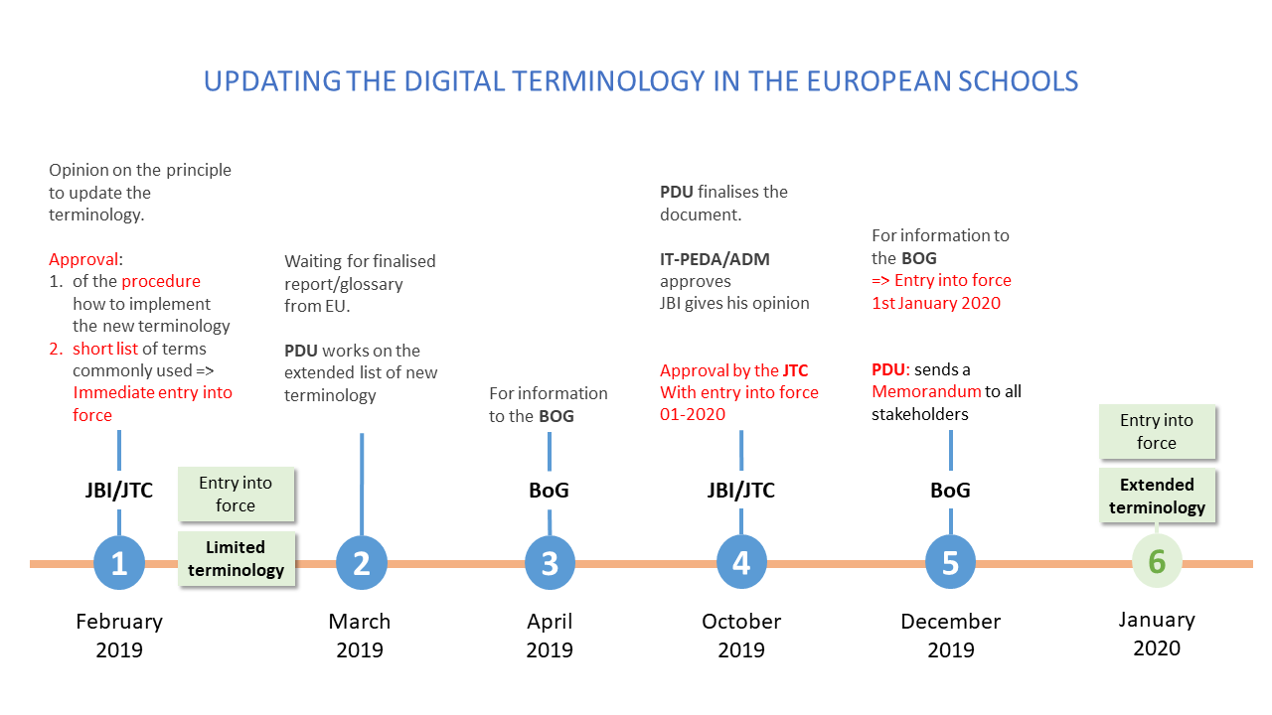

- Proposed procedure for implementation of the new terminology
The following procedure is proposed:
As of February 2019, the limited terminology will entry into force:
- All new documents will use the new terminology (meetings documents, new syllabuses, memos, emails…).
- Old documents will not be updated. In particular, current syllabuses will not be modified.
- Special case concerning ICT syllabuses. The responsible subject Inspectors may decide to adapt the titles only of the ICT syllabuses (not their content), before the date set for the official revision of these syllabuses.
As of 1st January 2020, the extended terminology will also entry into force:
- All new documents will use digital education terminology (limited and extended).

Opinion of the Joint Board of Inspectors:
The JBI gives a favourable opinion on the proposed timeline for an entry into force of the new terminology, expressed in the point 3 in the document, and on the proposed procedure for its implementation expressed in the point 4.
The JBI recommends that the JTC approve the proposals, as well as the short list of frequently used terms, for immediate entry into force.

Decision
The JTC approved the Digital Terminology for the European Schools system and its proposed timeline for implementation. The limited terminology would enter into force as of February 2019, the extended one would be presented during the school year 2019-2020. Consequently, every new document would use the new terminology, whilst the old ones would remain untouched, except for the ICT syllabuses, the titles of which (not the content) could be adapted accordingly depending on the decision of the responsible subject Inspector.

ANNEX 1 – LIMITED TERMINOLOGY TO BE APPROVED IN FEBRUARY 2019
PREFERED TERM | GERMAN | FRENCH | DEFINITION | ALTERNATIVE TERMS / SYNONYMES
Bring Your Own Device (BYOD) | BYOD | BYOD  AVEC (Apportez Votre Equipement personnel de Communication) | A policy where pupils and students bring to school personally owned (not school-provided) devices (laptop, smartphone or tablet) for class purposes, thus achieving a one-to-one (one device per student) regime.
Digital | Digital | Numérique | All that involves computer technologies (that allow the production, storage and processing of information in binary code).
Digital competence | Digitale Kompetenz | Compétence numérique | Digital competence is one of the eight key competencies. It involves the confident, critical, responsible and creative use of, and engagement with, digital technologies for learning, at work, and for participation in society. It includes information and data literacy, communication and collaboration, media literacy, digital content creation (including programming), safety (including digital well-being and competences related to cybersecurity), intellectual property related questions, problem solving and critical thinking. | Digital skills, digital literacy
Digital competence framework | Digitaler Kompetenzrahmen | Cadre de référence de la compétence numérique | A framework to help learners to thrive in an increasingly digital world. The European Schools Digital Competence framework is based on the the Digital Competence Framework developped by the European Commission, also known as DigComp. It sets out 21 competences, grouped in 5 key areas, to describe what it means to be digitally competent. It provides a common language on how to identify, teach and assess the key areas of digital competence.
Digital device | Digitales Gerät | Appareil numérique | A computer based device (in contrast with an analog device). It can receive, store, process and send digital information (in binary code).
Digital education | Digitale Bildung | Éducation numérique | Organized programs of learning that uses digital technologies and resources to improve learning outcomes, and that develop the digital competence needed to thrive in an age of rapid change.
Digital learning | Digitales Lernen | Apprentissage numérique | Any type of learning that is mediated by digital technology or by instructional practice that makes effective use of digital technology.
Digital learning technologies | Digitale Lerntechnologien | Technologies numériques d'apprentissage | The expanding range of digital technologies used to teach and to learn (devices, softwares, platforms...). | DLTs, Digital learning tools, Educational Technology, ICT and education, ICT for Learning and Skills, Technology Enhanced Learning (TEL)
Digital portfolio | Digitales Portfolio | Portfolio numérique | A digital collection of "artifacts" (dynamically enriched over time) that documents, showcases and facilitates pupils' and students' self-reflection on their learning growth, as well as it's assessment by teachers. A digital portfolio can include multimedia content and links to other online material. | eportfolio, e-portfolio, online portfolio
Digital strategy (for schools) | Digitale Strategie (für Schulen) | Stratégie numérique (pour les écoles) | A digital strategy is a process of transformation and development to adapt to the changing environment of the digital age. It is an up-to-date document that provides a rationale and an action plan for integrating efficiently digital technologies into teaching, learning and assessment practices in schools over the years.
Digital technology | Digitaltechnologie | Technologies numériques | A diverse and increasingly broad range of products based on processors responding to binary code (0 or 1) instructions and used to create, store, process and communicate information. E.g.: computers, smartphones, digital cameras, printers, robots.
Digital tools | Digitale Werkzeuge | Outils numériques | Digital technologies used for a given purpose or for carrying out a particular function of information processing, communication, content creation, safety or problem solving.
Online | Online | En ligne | Qualifies what is available on or performed using the Internet or other computer network (when "offline" indicates a disconnected state).
Online teaching/learning | Online lehren/lernen | Apprentissage/Enseignement en ligne | Teaching and learning that takes primarily over the Internet, facilitating flexibility and participant interaction. | E-learning
Web application (web app) | Webanwendung (Webapplikation) | application web | An application that can be used directly online using a web browser and, being installed on a server, does not require installation on client machines.
Webinar (Web conferencing) | Webinar | webinaire | An online session (conference or training), usually as either video or audio with slides, that can be attended live or afterwards as a recording.

ANNEX 2 – EXTENDED TERMINOLOGY _ DRAFT
Raw list of all proposed terms, with a number for priority (without definitions and other elements).3 21st Century skills

3 Acceptable use policy (AUP)
2 Accessibility (Assistive technologies)
3 Adaptive learning
3 Adaptive Learning
3 Agency in learning
3 API
3 Apps
3 Asynchronous
4 Biased site
2 Blended learning (Hybrid Learning)
3 Blocking
1 Bring Your Own Device (BYOD)
3 Classroom Response System
2 Cloud
3 Coding (programming)
4 Coding club
3 Computer
4 Computer simulation
3 Content in different formats
2 Content Management System (CMS)
3 Content repository
3 Copyright
3 Creative commons
4 Cyber Hygiene
3 Cyber safety
3 Cyberbullying
4 Data culture
3 Data privacy
3 Data protection
3 Data security
3 DigComp
3 DigCompOrg
1 Digital
3 Digital badge
3 Digital citizenship
3 Digital collaborative workspace
3 Digital communication
1 Digital competence
1 Digital competence framework
3 Digital content
1 Digital device
4 Digital divide
1 Digital education
3 Digital environment
3 digital footprint
3 Digital infrastructure
1 Digital learning
4 Digital learning / E-learning
2 Digital learning coordinator
2 Digital learning environment
1 Digital learning technologies
3 Digital Learning Technologies and Resources (DLT&R)
3 Digital literacy
3 Digital pedagogical competence
1 Digital portfolio
3 Digital safety (cybersecurity)
3 Digital services (public or private)
4 Digital services (public or private)
3 Digital skills
1 Digital strategy (for schools)
3 Digital teaching materials
1 Digital technology
1 Digital tools
4 Digital use divide
3 Digital-age content
3 Discussion forum
1 Distance learning/teaching
3 Document management
4 E-book, e-reader, E-textbook
3 Educational technology
4 Email filter
4 Email scan
4 Encryption
4 End User
4 Fair use
3 Flipped classroom
4 Front User
3 ICT - Information and Communication Technology (see digital technologies)
3 Information and communication technology (ICT) skills
3 Innovative use of digital technologies
3 Integration of digital technologies
3 Interactive whiteboard
3 "knowledge society / knowledge-based society"
3 Laptop
3 Learning Analytics
2 Learning Management System (LMS)
4 Log file
3 Maker spaces
3 Makers, Maker movement
3 Massive Open Online Course (MOOC)
3 Media Literacy
4 Mind map
3 Mobile device
3 Mobile Learning (mLearning)
4 Monitor magnification software
2 Multimedia
4 Non-authoritative website
2 One-to-one computing (1:1)
1 Online
3 Online course
3 Online library
3 Online platform (in education)
3 Online safety (Cyber Security)
3 Online teachers’ networks or communities of practice
3 Open badges
4 Open Education
4 Open Educational Resources (OERs)
3 Open license
3 "Open Source Software"
3 Personal Learning Network (PLN)
3 Privacy
3 Privacy policy
3 Programming
3 Repository
3 Robotics
3 SaaS (hosted application)
3 SCORM
4 SIS
4 Source code
3 Student Information System (SIS)
3 Student Response Systems
4 Synchronous tools
3 Tablet
4 Technical support
3 Technology
4 Text-to-speech tool
4 Total cost of ownership (TCO)
4 Transformative budgeting for digital learning
4 Universal Design for Learning (UDL)
4 Usable design
3 Video conference
4 Video projector (data projector)
3 Virtual learning environment (VLE)
3 Virus
4 Visual programming language
4 Visualization tools
1 Web application (web app)
1 Webinar (Web conferencing)
3 Wiki

EUCO 14/17: European Council conclusions of 19 October 2017. https://data.consilium.europa.eu/doc/document/ST-14-2017-INIT/en/pdf
EU Member States stressed their commitment to providing young people with the ‘best education and training’. https://www.consilium.europa.eu/en/press/press-releases/2017/03/25/rome-declaration/
https://ec.europa.eu/education/education-in-the-eu/digital-education-action-plan_en (January 2017).
Council Recommendation of 22 May 2018 on key competences for lifelong learning (Text with EEA relevance) (2018/C 189/01). https://eur-lex.europa.eu/legal-content/EN/TXT/?uri=CELEX%3A32018H0604%2801%29
Digital Competence Framework for Citizens (DigComp: https://ec.europa.eu/jrc/en/digcomp), Digital Competence Framework for Educators (DigCompEdu: https://ec.europa.eu/jrc/en/digcompedu).

